
RODOLFO V. FELICIANO MEMORIAL HIGH SCHOOL
San Pedro II, Magalang, Pampanga
A Rule-Based Bitcoin Trading Strategy Tested Against Dollar-Cost Averaging, 2022 to 2026

Research Paper

By:
Pasok, Charles Gideon T.
Esguerra, Eireen Joy U.
Valerio, Euan Deign D.

Research Adviser:
Patrick Yambao

A Rule-Based Bitcoin Trading Strategy Tested Against Dollar-Cost Averaging, 2022 to 2026
By: Pasok, Charles Gideon : Esguerra, Eireen Joy : Valerio, Euan Deign
Adviser: Patrick Yambao
School: Rodolfo V. Feliciano Memorial High School
Region III
ABSTRACT
From 2022 to 2026, buying a fixed amount of Bitcoin every week ended with more money than a rule-based trading strategy: $22,312.94 against $13,417.77 from the same $10,000, though the strategy won 70.37% of its 27 trades. The strategy combines MACD, KDJ, ATR, and Smart Money Concepts Order Blocks. Its rules were set by eye on 2018 to 2022 charts and fixed before testing, then applied to 8,767 four-hour candles as unlevered long and short futures trades. Before costs it returned +30.31% (one-sided exact binomial p = 0.0261). After a 0.20% round-trip cost, p rose to 0.1239; with stops checked against candle highs and lows, it was 0.061 even before costs. After costs, the 95% bootstrap interval on total return was [+0.59%, +49.59%] with trades resampled singly but [−1.29%, +49.96%] with runs of consecutive trades resampled, so the return was positive before costs but not clearly above zero after. Inside a weekly buying plan, moving 30% of contributions into the strategy raised the after-cost Sharpe ratio from 0.555 to 0.621 and cut the worst drop from −36.02% to −26.43%, slightly better than holding that 30% as cash (0.585, −27.34%). A January to July 2026 forward test lost 3.45% over four trades. Removing any one indicator gate lowered average return per trade, but not significantly after a Holm correction, and on 1-hour candles the rules lost 0.18% per trade after costs (p = 0.696). Costs decided whether the win rate was significant; weekly buying won on final value either way.
Keywords: Bitcoin, algorithmic trading, backtesting, dollar-cost averaging, Smart Money Concepts, technical analysis

Table of Contents

Introduction 6
Significance of the Study 11
Statement of the Problem 13
Hypotheses 13
Framework 16
A. Research Design 16
B. Materials and Sources 17
C. Variables 19
D. Strategy Formulas 20
E. Portfolio Construction and Contribution Schedule 26
F. Data Analysis 29
Findings 34
Answers to SOP 1 and Hypothesis H₁ 34
Answers to SOP 2 and Hypothesis H₂ 41
Answers to SOP 3 45
Conclusions 51
Limitations 53
Delimitations 56
Summary and Conclusion 57
References 59
Appendix A 63
Statistical Provenance of Every Reported Number 63
Appendix B 69
Source Form of Every Formula Written for This Study 69
Appendix C 70
Complete Trade Log for the Primary Window 70
Appendix D 73
Recomputing Every Number by Hand 73

Introduction
Money has moved online over the last thirty years, and phones and digital payments have brought financial services to far more people. Across 123 economies, 76% of adults had a formal financial account by 2021, up from 51% in 2011, mostly through mobile money and e-wallets in developing countries (Demirgüç-Kunt et al., 2022). For many people, these tools are the only bank they have.
Cryptocurrency is one product of this shift. A cryptocurrency is a digital asset whose ownership is recorded on a blockchain, a public ledger kept by many computers instead of one bank. It can be traded directly, with no bank or broker, using only a phone and an internet connection (Schär, 2021). In places like Magalang, Pampanga, where bank branches are few, crypto platforms are often a person's first way into global markets.
Many young people learn about money by investing it. In a 2022 United States survey of adults aged 18 to 25, 56% already held investments; of these, 55% owned cryptocurrency, 41% owned individual stocks, and nearly half got their investing information mainly from social media (FINRA Investor Education Foundation & CFA Institute, 2023). Filipino studies show the same link between knowledge and investing. Among 384 college students in Metro Manila, financial knowledge was the only significant predictor of stock investing (Arena et al., 2023), and among 435 millennial workers in Makati, higher financial literacy went with greater acceptance of cryptocurrency (Magbitang et al., 2023).
Bitcoin launched in 2009 as the first fully decentralized cryptocurrency (Nakamoto, 2008). It trades around the clock, has no circuit breakers, and has no central bank or company earnings behind it. Its price therefore swings more than most assets, which is both its main risk and its main opportunity.
When a very large buyer or seller pushes price hard, the chart usually shows the price area where that position was built before the move. Smart Money Concepts, a practitioner trading framework, calls these areas Order Blocks; this study uses the LuxAlgo version (LuxAlgo, 2022). The term comes from trading practice, not research. Research does support the narrower idea behind it: large traders split and time big orders, which moves both resting orders and short-term price (Bessembinder et al., 2009; Biais et al., 2005). The strategy waits for price to return to such an area, checks that the pullback is weakening, enters, sets its stop by current volatility, and exits when momentum fades.
Because Bitcoin trades non-stop and reacts fast to sentiment, fundamentals help little with short-term decisions. Traders use technical analysis instead: forecasting price from past price and volume (Svogun & Bazán-Palomino, 2022). It assumes that price already reflects what the market knows and that people repeat their behavior, so chart patterns may repeat. The evidence is mixed. Technical rules have shown short-term predictive value in liquid crypto markets (Corbet et al., 2019), but Fang et al. (2014) found that simple technical rules lost their power on data they had not been fitted to. That is why this study keeps a forward test and a holdout.
This study combines three kinds of tools. Each answers a different question about price: which way it is likely to move, how hard it is moving, and where large traders have already acted.
The first is MACD (Moving Average Convergence Divergence). It plots the gap between a fast and a slow moving average as a histogram, which shows whether momentum is building or fading (Chong & Ng, 2008). It reports current momentum; it does not predict reversals. On 60 years of London Stock Exchange data, MACD beat buy-and-hold in most of the cases tested (Chong & Ng, 2008). On 178 Philippine stocks over 12 years, about 35% were consistently profitable under standard MACD settings and about 51% under a faster setting (Navarro & Navarro, 2023). Because results vary this much with market and settings, this study measures MACD's contribution directly. Here the histogram's slope is the momentum check: below zero but rising favors a long, and above zero but falling favors a short.
The second is the KDJ oscillator, which moves within a fixed range, so readings near either end flag unusual conditions. It is a stochastic oscillator with an extra line, J, that makes disagreements between price and momentum easier to see. It starts from the Raw Stochastic Value: where the close sits within the high-to-low range of recent candles. K and D smooth that value, and J is three times K minus two times D, so it reacts faster than either (Wu & Diao, 2015). On eight years of Shanghai and Shenzhen data, MACD, RSI, and KDJ together predicted short-term moves better than the market period alone would explain (Wu & Diao, 2015), and KDJ and related indicators gave statistically and economically significant stock-return forecasts, in-sample and out-of-sample (Dai et al., 2020). Neither paper builds a full entry-and-exit strategy around KDJ, which is part of the gap this study addresses.
This study uses two separate KDJ calculations. The first is a fixed nine-period series over the whole dataset; it decides entries and never changes. The second runs only while a trade is open, to time one kind of exit. Its window adapts to the number of candles between the Order Block that triggered the trade and the entry candle; across the 27 trades it ranged from 14 to 439 candles, with a median of 74. This ties exit timing to the structure behind the trade while keeping entries fixed.
The third tool, the Average True Range (ATR) introduced by Wilder (1978), measures how hard price is moving, not which way. True range is the largest of three numbers: the high minus the low, the gap between the high and the previous close, or the gap between the low and the previous close. ATR averages it over a window. A 14-period ATR sets the stop-loss distance, the trailing exit, and one profit-taking exit; a 200-period ATR gives a long-run baseline used to filter market conditions and judge Order Blocks. With two windows, risk settings scale with conditions instead of sitting at fixed levels.
Here ATR sets only distances, not position size. Many trading desks risk the same dollar amount on every trade and shrink the position when ATR is wide; this study does not. The stop sits a multiple of ATR from entry, wider in volatile markets and tighter in calm ones, and the trailing and profit-taking exits are measured in ATR too. Every trade uses the full account at 1x, with no borrowed money (Section E).
None of these tools accounts for very large participants. Smart Money Concepts tries to, by reading raw price structure instead of statistical averages. Its practitioners argue that large traders need resting orders on the other side to fill big positions, so price tends to return to where such a position was built (LuxAlgo, 2022). That is a trading heuristic, not an established finding; the studies above support only the narrower point that large orders are split and timed. Order Blocks are detected at two levels, a 50-candle lookback for larger swings and a 5-candle lookback for smaller structure, and each is judged against five quality criteria (Section D).
Earlier studies tested MACD, KDJ, chart patterns, and other technical rules alone or in pairs (Chong & Ng, 2008; Corbet et al., 2019; Lv et al., 2017). We found none that tests MACD, an adaptive KDJ exit, a dual-ATR risk framework, and Order Block detection together in one cryptocurrency backtest. The gap is not whether each tool works alone, which has been studied, but what combining them does, for better or worse, compared with the passive options an ordinary participant would use. This study addresses that gap.
A strategy only matters compared with what a person would otherwise do. For most retail participants that is not another algorithm, but dollar-cost averaging (buying a fixed amount on a fixed schedule regardless of price) or a single lump-sum purchase held without further action. Dollar-cost averaging is the default recurring-buy feature of most exchanges and savings apps, and the standard baseline in research on systematic retail investing (Finlay & Zorn, 2023). Constantinides (1979) showed it is suboptimal under standard expected-utility assumptions, because delaying investment gives up expected return. Statman (1995) argued it survives anyway because it meets behavioural needs, such as regret aversion and self-control. Weak in theory but dominant in practice, it is the right benchmark for a study aimed at ordinary participants. This paper therefore tests the strategy against weekly dollar-cost averaging and lump-sum buy-and-hold over the same window from the same capital, then asks a practical question: does putting part of a weekly buying plan into the strategy improve the plan?
The rules were built on one period and tested on another. Every rule, parameter, and threshold was set by eye from BTC/USDT charts over January 2018 to January 2022, drawing on prior trading experience. That period was never fed into a search, sweep, or optimizer, and no parameter was adjusted to improve a measured result. The main findings come from January 2022 to January 2026, which the rules were not built on.
Two follow-up analyses were added after these results were fixed. Each was pre-specified: its tests, resample counts, and random seeds were written into a dated file before any of its numbers were computed. The files, experimental/PREREGISTRATION.md and experimental/PREREGISTRATION_1H.md, were both committed on 2026-10-26 and are headed "Status: EXPLORATORY". The decision to include them in this paper was made after their results were read. The first file's primary test, a machine-learning trade filter, failed and is reported in Limitation 14. The first analysis asks how much each of the four indicator gates contributes to the result. The second asks whether the same rules still work on 1-hour candles, which give four times as many candles and could, in principle, give more trades. Together they form the third research question, answered under SOP 3 in the Findings.

Significance of the Study
Access to financial services in the Philippines has grown much faster than participation in markets. The share of Filipino adults with an account rose from 29% in 2019 to 56% in 2021, driven mostly by e-money accounts (8% to 36%), while investment uptake, excluding pension contributions, fell from 15% to 10% (Bangko Sentral ng Pilipinas, 2022). More Filipinos can reach a market than ever, but fewer are invested in one.
This study speaks to that gap. Open, reproducible research gives a first-time participant more than a screenshot of someone's returns: a full rule set, the data it was tested on, and an honest account of where it failed. The work supports United Nations Sustainable Development Goal 8, on inclusive economic growth, by turning market participation into transparent, repeatable rules (United Nations, 2015). It also supports financial literacy: young people mostly meet trading through screenshots of gains, and this study shows a complete rule set tested against simple weekly saving, losses included. It uses only public data and open-source tools, so it can be reproduced anywhere.
Responsible use. This paper is a research report, not investment advice, and it does not recommend buying, selling, or holding Bitcoin or any other asset. Cryptocurrency carries a high risk of loss: over this window, a single Bitcoin purchase at one point stood 66.93% below its earlier peak at a daily close (Table 10). In the Philippines, platforms that exchange or hold cryptocurrency for customers are regulated by the Bangko Sentral ng Pilipinas as virtual asset service providers (Bangko Sentral ng Pilipinas, 2021), and the Philippine Securities and Exchange Commission also regulates crypto-asset service providers. Anyone who trades should use a registered platform and only money they can afford to lose. Is this gambling? No money was traded. The study tested whether fixed, published rules beat simple saving and found that they did not, the opposite of a get-rich claim.

Statement of the Problem
Bitcoin is hard to forecast over short periods. It trades 24 hours a day, moves sharply, and forms price structure that practitioners attribute to large participants. MACD and KDJ have each shown predictive value alone. What has not been tested is how they perform combined with volatility-based risk management and Order Block detection, and how that compares with the passive options an ordinary participant would use.
This study answers three questions, called SOP 1 to SOP 3 (for Statement of the Problem):
1. How well does the combined MACD, KDJ, ATR, and Smart Money Concepts strategy predict short-term Bitcoin price moves, measured by win rate, total return, and average return per trade?
2. Starting from the same capital, how does the strategy compare with weekly dollar-cost averaging into Bitcoin and a single lump-sum purchase held to the end of the window, on total return, Sharpe ratio, maximum drawdown, and time in market? And does moving a growing share of new weekly contributions into the strategy improve the risk-adjusted profile of an ordinary dollar-cost-averaging plan?
3. Can the strategy trade more often without lowering its return per trade? This is judged by how much each of the four indicator gates (a gate is a condition that must be true before a trade is allowed: the MACD histogram, KDJ, K-acceleration, and ATR-regime gates) adds to average return per trade, and by whether the same rules keep a positive average return per trade after costs on 1-hour instead of 4-hour candles?
Hypotheses
H₁: The combined strategy produces a statistically significant win rate above 50% on BTC/USDT 4-hour candles over the January 2022 to January 2026 test window.
In plain terms: does the strategy win more often than a coin flip by too much to be luck? It is tested with a one-sided exact binomial test (Section F) on the trades after a 0.20% round-trip cost, the cost a real trader would pay (Table 4). That cost basis was not written down before the gross result was known, so the gross result is reported beside it. With 27 trades the test has limited power (Limitation 2), so a non-significant result is inconclusive, not evidence that no edge exists.
H₂: Blending a strategy allocation into a Bitcoin dollar-cost-averaging plan improves that plan's risk-adjusted profile, as measured by the Sharpe ratio and maximum drawdown, relative to a plan held entirely in dollar-cost-averaged Bitcoin.
Stating the hypothesis formally fixes the direction of the claim before the numbers are seen, but its decision rule is stricter than the sentence above. A strategy sleeve sits in cash about 97% of the time, and moving part of a weekly plan into cash would smooth it whatever the strategy does. H₂ is therefore judged against a cash control: the same 10%, 20%, and 30% shares held as cash earning nothing. H₂ is supported only if, at every share, the strategy sleeve beats the cash sleeve on both the Sharpe ratio and maximum drawdown, after a 0.20% round-trip cost on every strategy trade and a 0.10% markup on every Bitcoin purchase. The cash control and this rule were added after an outside review of an earlier draft, when the blended results without the control were already known. The rule is descriptive: formal tests for a difference between Sharpe ratios exist (Ledoit & Wolf, 2008) but were not run, so H₂ has no p-value.
The third research question has no hypothesis of its own, because its two follow-up analyses were added after the headline result was known. Its gate comparison sets nine gate settings against the full rule, so nine tests run at once. With nine tests and no real effect, at least one would still fall below 0.05 about 37% of the time by luck alone, assuming independent tests (1 − 0.95⁹ = 0.37). Each p-value is therefore adjusted with the Holm method (Holm, 1979), and the comparison is treated as exploratory, even though no gate setting was changed to answer it.
Its 1-hour part has one pre-registered test, which is not a study hypothesis: do the unchanged rules earn a positive average return per trade after a 0.20% round-trip cost on 1-hour BTC/USDT candles over 2022 to 2026? The null hypothesis is H₀: μ_net ≤ 0, rejected if the one-sided p is below 0.05. The test, resample count, and random seed were pre-registered before any 1-hour indicator or trade was computed. It uses average return after costs rather than win rate, because a faster timeframe can change how large wins and losses are, not only how often they happen. The H₁ win-rate test is also reported for comparison.

Framework

A. Research Design
This is a retrospective quantitative backtest. The strategy runs candle by candle over historical BTC/USDT 4-hour data, as it would have traded in real time, and never sees a candle that had not closed when a decision was made. No parameter was fitted, swept, or optimized against the measured outcome.
The rules, parameters, and thresholds were set by eye from January 2018 to January 2022 charts. The main findings come from January 2022 to January 2026. A stricter third test uses January to July 2026, after every change to the strategy code. Figure 1 shows the three periods.
This separation has two limits. First, the build period was read by eye, not fitted numerically, so the rules carry whatever bias visual pattern recognition brings, and the separation cannot be measured like a held-out split in a machine-learning study. Second, the 2022 to 2026 window is unseen for rule building but not for code checking, because the bug described in the Limitations was found while examining it. Only the January to July 2026 test is unseen in both senses.
The two follow-up analyses keep the same windows, with one addition. The gate comparison in SOP 3 runs separately on the 2018 to 2022 and 2022 to 2026 windows. The 1-hour test uses 2022 to 2026 as its main window and adds a one-time holdout, 2026-08-08 to 2026-10-26, that no version of the strategy had seen; the script that reads it refuses to run twice. Figure 1 shows only the three 4-hour periods.
Figure 1
Relationship Between the Formulation Period, the Primary Reported Window, and the Forward Test
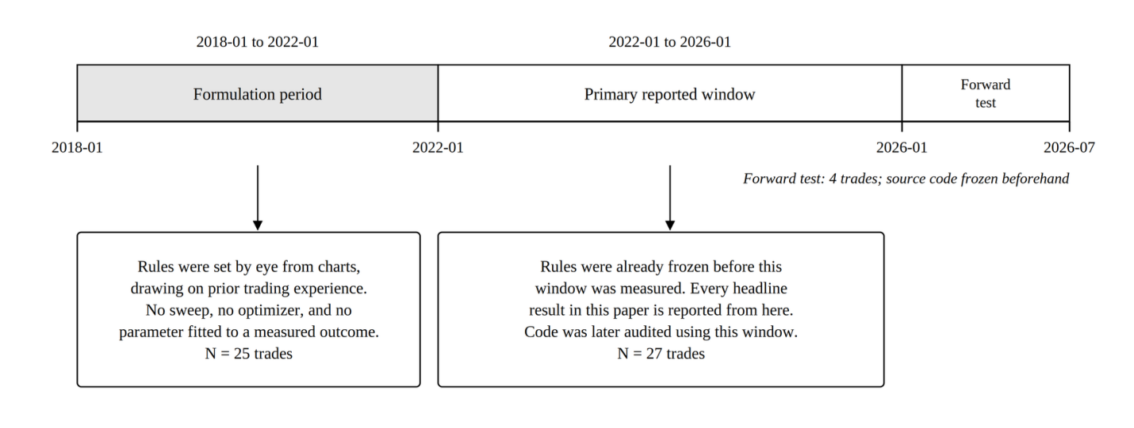

B. Materials and Sources
BTC/USDT 4-hour candlestick data (Binance, via API). Open, high, low, close, and volume were pulled from the Binance public price endpoint for BTCUSDT at 4-hour resolution, in batches of 1,000 candles. Millisecond timestamps were converted to datetimes and shifted forward eight hours, so all stored 4-hour timestamps are UTC+8; only the 1-hour data below is kept in UTC. These are spot prices. The strategy is modelled as trading the BTCUSDT perpetual futures contract (Section E), and spot prices stand in for it; the small, changing gap between the two, called the basis, is not modelled. Figure 2 shows the collection and verification steps.
Figure 2
Data Collection, Timestamp Conversion, and Dataset Verification
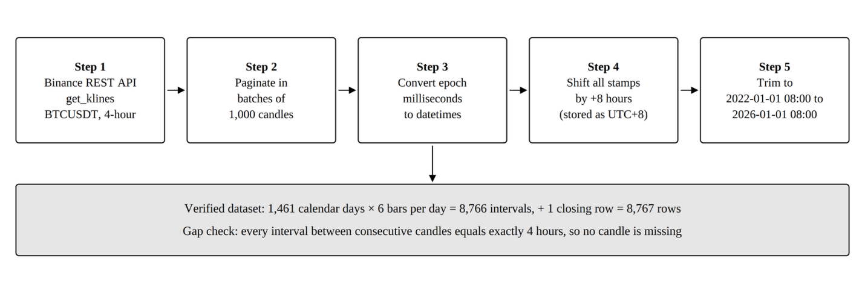
The dataset runs from 2022-01-01 08:00:00 to 2026-01-01 08:00:00, exactly 1,461 days (365 + 365 + 366 + 365, the 366 covering the 2024 leap day). At six 4-hour candles a day that is 1,461 × 6 = 8,766 intervals, and the closing candle is stored as its own row, so the file holds 8,766 + 1 = 8,767 rows. Every gap between consecutive candles is four hours, with no duplicates and no missing candle.
The 2018 to 2022 build window holds 8,750 rows against 8,767 expected: seventeen candles missing across eight exchange outages, the largest a seven-candle gap. This does not affect any figure from the primary window.
BTC/USDT 1-hour candlestick data (Binance, via API). For the 1-hour test in SOP 3 only, 1-hour candles were pulled once from the same endpoint on 2026-10-26: 77,164 closed candles from 2018-01-01 00:00 to 2026-10-26 05:00, kept in UTC with no eight-hour shift. The feed has 27 gaps totalling 122 missing hours, all but one in 2018 to 2021, left unfilled as in the 4-hour data. Combined back into 4-hour candles, 18,826 of 18,828 matched the 4-hour file exactly. Of the other two, one sits on a missing hour and the other is the 4-hour file's last candle, still open when that file was saved.
Python 3 environment. Backtesting logic was implemented using pandas, numpy, python-binance, and gspread with oauth2client.
SciPy. A free, open-source scientific library for Python, widely used in published research (Virtanen et al., 2020). Every standard textbook test in this paper is an unmodified scipy.stats call.
Google Sheets and SQL database. Simulation results were exported to Google Sheets and to a local SQL database, including per-trade records.
LuxAlgo Smart Money Concepts indicator (LuxAlgo, 2022). Order Block detection is a Python translation of the LuxAlgo indicator for TradingView, using a 50-candle swing pivot lookback and a 5-candle internal pivot lookback.
Average True Range (Wilder, 1978). True range follows Wilder's definition, but both ATR windows use a plain rolling mean rather than Wilder's exponential smoothing, because that is what the code does.
Web-based verification dashboard. A separately written JavaScript dashboard recomputes the indicators and entry conditions in the browser, as a cross-check from a second codebase. Its scope is deliberately narrow: it does not detect Order Blocks, Fair Value Gaps, or liquidity sweeps, and it imports nothing from the Python analysis. Because of that independence, the two bootstrap intervals in the Findings are reported separately, not merged.

C. Variables
Independent variable. How capital is allocated over the same price history, at six levels. Three are standalone arms: the strategy alone, weekly dollar-cost averaging into Bitcoin, and one lump-sum purchase held to the end. Three are blends that put 10%, 20%, or 30% of new weekly contributions into the strategy and dollar-cost average the rest. The 0% blend is pure weekly averaging and serves as the blend's baseline row.
Dependent variables. For the strategy's own trades: win rate, total return before and after costs, average return per trade, and return concentration. For the comparison against passive options: total return and final capital from a fixed start, annualized Sharpe ratio, maximum drawdown, and time in market.
Controlled variables. Trading pair, candle interval, and backtest window are the same for every arm. The MACD, KDJ, and ATR settings, exit rules, and minimum reward-to-risk are the same wherever the strategy appears. Every head-to-head arm starts with $10,000. The averaging arm and every blend use 210 equal weekly contributions. Within a comparison, every arm pays the same cost rate.
Follow-up analyses. In the SOP 3 gate comparison, the independent variable is which entry gates are on: nine settings plus the full rule. In the 1-hour test it is the candle interval, at three levels: 4-hour; 1-hour with every setting unchanged (the literal version); and 1-hour with every window stretched four times (the time-scaled version). The dependent variables are trade count, trades per year, win rate, and average and total return per trade before and after a 0.20% round-trip cost. Every Table 1 threshold, every exit rule, and the Order Block detection code are held fixed.

D. Strategy Formulas
Throughout this section, C, H, L, and V with subscript t denote the closing price, high, low, and traded volume of candle t.
MACD (12, 26, 9). Momentum comes from the gap between a fast and a slow exponential moving average, using only past and present candles.
${EMA}_{12}(t) = C_{t} × \frac{2}{13} + {EMA}_{12}(t−1) × (1 − \frac{2}{13})$
${EMA}_{26}(t) = C_{t} × \frac{2}{27} + {EMA}_{26}(t−1) × (1 − \frac{2}{27})$
${MACD}_{t} = {EMA}_{12}(t) − {EMA}_{26}(t)$
${Signal}_{t} = {MACD}_{t} × \frac{2}{10} + {Signal}_{t−1} × (1 − \frac{2}{10})$
${Hist}_{t} = {MACD}_{t} − {Signal}_{t}$
ATR (14) and ATR (200). True range measures how far price travelled on a candle. ATR averages it.
${TR}_{t} = max\left(H_{t} − L_{t} , \left|H_{t} − C_{t−1}\right| , \left|L_{t} − C_{t−1}\right|\right)$
${ATR}_{14}(t) = \frac{1}{14} × \sum_{i=0}^{13}{}{TR}_{t−i}$
${ATR}_{200}(t) = \frac{1}{200} × \sum_{i=0}^{199}{}{TR}_{t−i}$
ATR₁₄ sets stop-loss distance, the minimum-stop filter, the trailing exit, and the ATR-move exit. ATR₂₀₀ is the volatility baseline for the market-condition filter and for two Order Block criteria, Displacement and Large Origin Candle.
KDJ (9, 3, 3), the fixed entry gate. Computed once over the whole dataset; every K, D, and J value in the entry conditions reads this series at the current candle.
${RSV}_{t} = \left[\frac{C_{t} − min L across the last 9 candles}{max H across the last 9 candles − min L across the last 9 candles}\right] × 100$
$K_{t} = \frac{2}{3} K_{t−1} + \frac{1}{3} {RSV}_{t}$
$D_{t} = \frac{2}{3} D_{t−1} + \frac{1}{3} K_{t}$
$J_{t} = 3K_{t} − 2D_{t}$
KDJ, the adaptive exit series. A second, separate system that only times one exit after a trade is open and never shares state with the fixed series. At entry it is seeded from the fixed series' K and D at the entry candle. Its window length is set once and held for the life of the trade:
$w = max\left(1, candles elapsed since the Order Block\right)$
On each later candle, the Raw Stochastic Value is recomputed over a rolling window of length w, and K and D are updated with the same one-third smoothing:
${RSV}_{custom} = \left[\frac{C_{cur} − min L across the window}{max H across the window − min L across the window}\right] × 100$
$K_{cur} = \frac{2}{3} K_{prev} + \frac{1}{3} {RSV}_{custom}$
$D_{cur} = \frac{2}{3} D_{prev} + \frac{1}{3} K_{cur}$
Across the 27 trades, w ranged from 14 to 439 candles, with a median of 74. Only w varies between trades; the entry gate never does. These are two separate systems by design.
Order Block detection. Two independent passes run over the same price series: one with a 5-candle pivot lookback for internal structure and one with a 50-candle lookback for swing structure. Figure 3 shows the detection and scoring steps.
Figure 3
Order Block Detection, Quality Scoring, and Eligibility
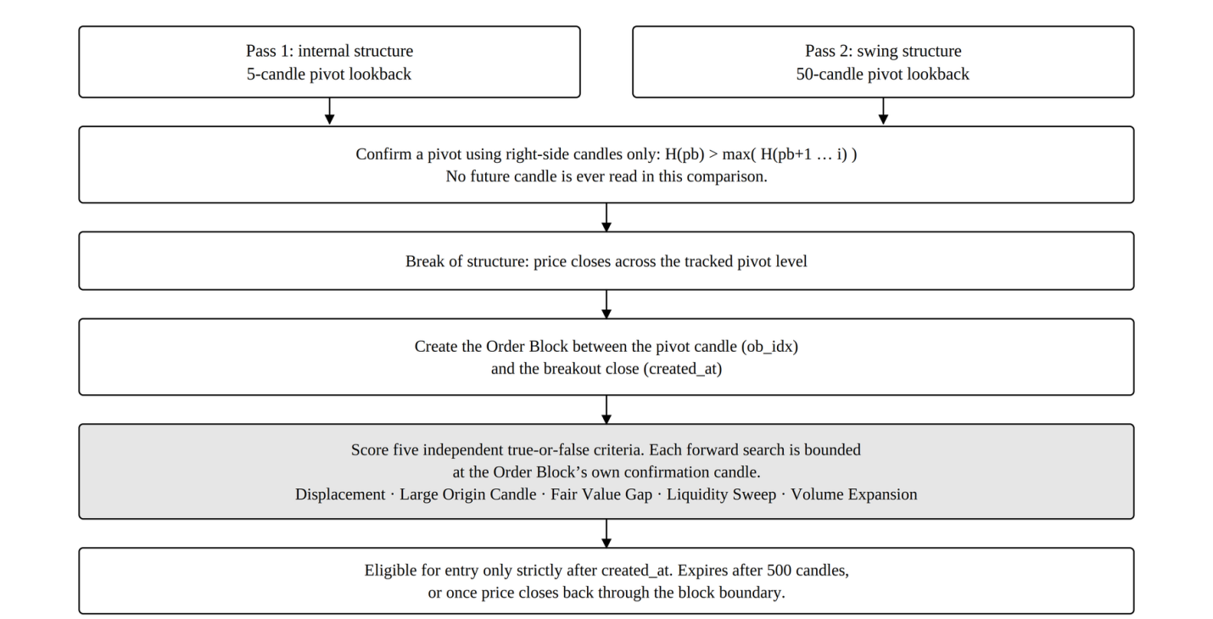
In each pass, a candle becomes a pivot high only by right-side comparison: its high must exceed every following high up to the breakout candle. A pivot low is the mirror. No future candle is read. A break of structure is flagged when price closes across a tracked pivot, and an Order Block is created from the segment between the pivot candle and the candle whose close confirms the break. Two candles are tracked separately on purpose: the one holding the Order Block's extreme and the one where the breakout closes. An Order Block can trigger an entry only after its confirmation candle. It expires after 500 candles, or as soon as price closes back through its boundary.
Order Block quality criteria. Each Order Block is scored on five true-or-false criteria. Their sum, 0 to 5, is used only as an eligibility threshold, which is 0 in the baseline, so no Order Block is excluded by score.
1. Displacement: within the candles immediately following the Order Block's own candle, and bounded at that Order Block's own confirmation candle, a candle body move of at least 1.5 times ATR₂₀₀ occurs in the Order Block's direction.
2. Large Origin Candle: the Order Block candle's high minus low is at least ATR₂₀₀ at that candle, so the candle is at least as tall as the long-run average.
3. Fair Value Gap: a three-candle price imbalance exists within a bounded window following the Order Block's candle. For a demand block the low of the third candle exceeds the high of the first; for a supply block the mirror condition holds.
4. Liquidity Sweep: the low of the Order Block's candle is at or below the minimum low over the prior ten candles for a demand block, or its high is at or above the maximum high over the prior ten candles for a supply block.
5. Volume Expansion: the volume of the Order Block's candle is at least 1.25 times the mean volume over the prior twenty candles, or the candle body exceeds 60% of the candle's own high-to-low range.
Both the Displacement and the Fair Value Gap search windows are bounded at the Order Block's own confirmation candle.
Fixed parameters. Every value below was set before, and independently of, the analysis reported here.
Table 1
Fixed Strategy Parameters
Parameter | Value
Minimum stop distance | 0.015, meaning 1.5% of entry price
KDJ J cap, long entries | 60.0
KDJ K cap, long entries | 50.0
KDJ K floor, short entries | 70.0
KDJ J cap, short entries | 100.0
ATR-move take-profit multiple | 1.8
Breakeven-stop trigger multiple | 2.0 (never fires; see note)
Minimum reward-to-risk ratio | 1.5
Order Block expiry | 500 candles
Internal pivot lookback | 5 candles
Swing pivot lookback | 50 candles
Note. Every value was set during the 2018 to 2022 formulation period and never adjusted; no dated record of when the values were fixed survives (Limitation 3). The breakeven-stop trigger never fires: the ATR-move exit at 1.8 times ATR is checked first, so any trade whose close moves 2.0 times ATR in its favour has already exited. The rule is kept as frozen and changes no result.
Entry conditions. A long entry needs all six conditions in Figure 4 at the same candle close and is entered at that close. A short is the mirror against a supply Order Block, with K above 70 and J at or below 100.
Figure 4
Long Entry Decision Sequence
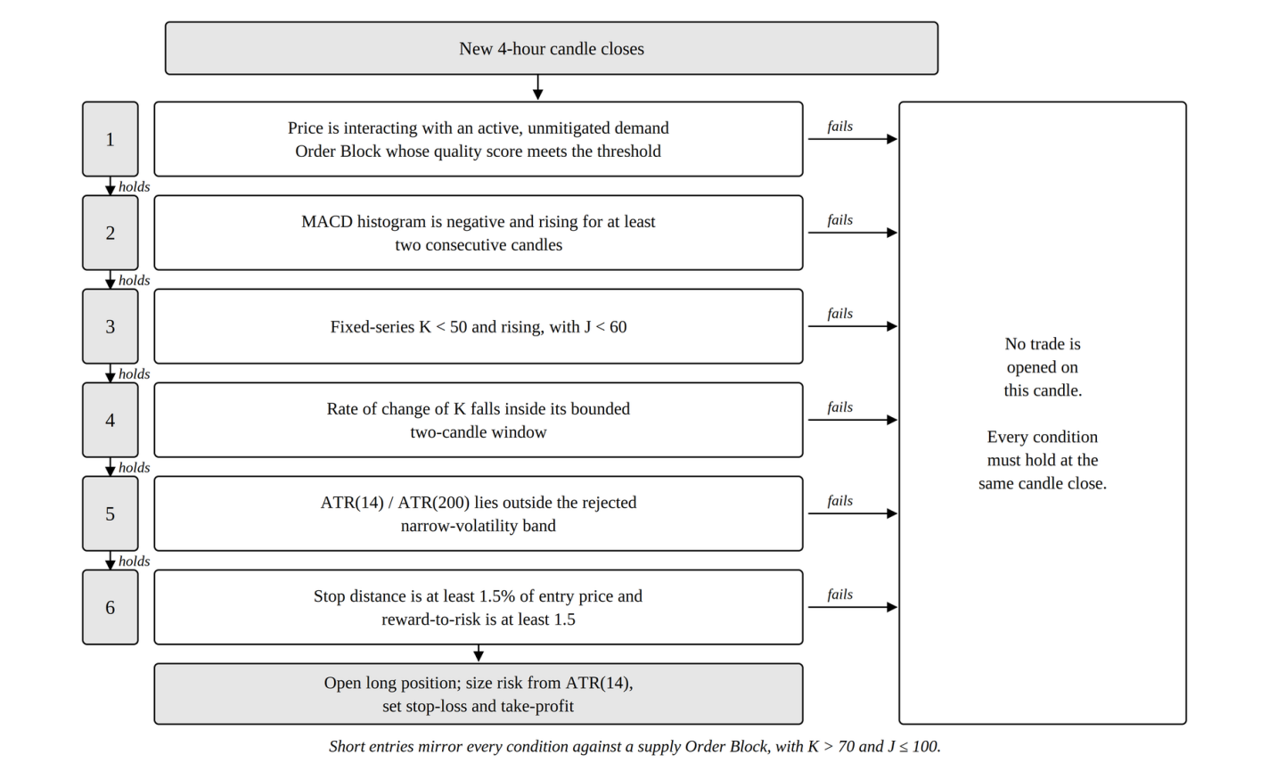
Exit conditions. Exits are checked on every candle in the fixed order in Figure 5; the first condition met triggers the exit. Every exit, including the stop-loss, is checked against the candle's close and filled at that close. A real stop order fills as soon as price touches it, even inside a candle, so this close-based stop can miss a stop that price touched and left, and can book a loss larger than the stop distance. Table 5 reruns the 27 trades with the stop checked against each candle's high and low.
Figure 5
Exit Priority Order
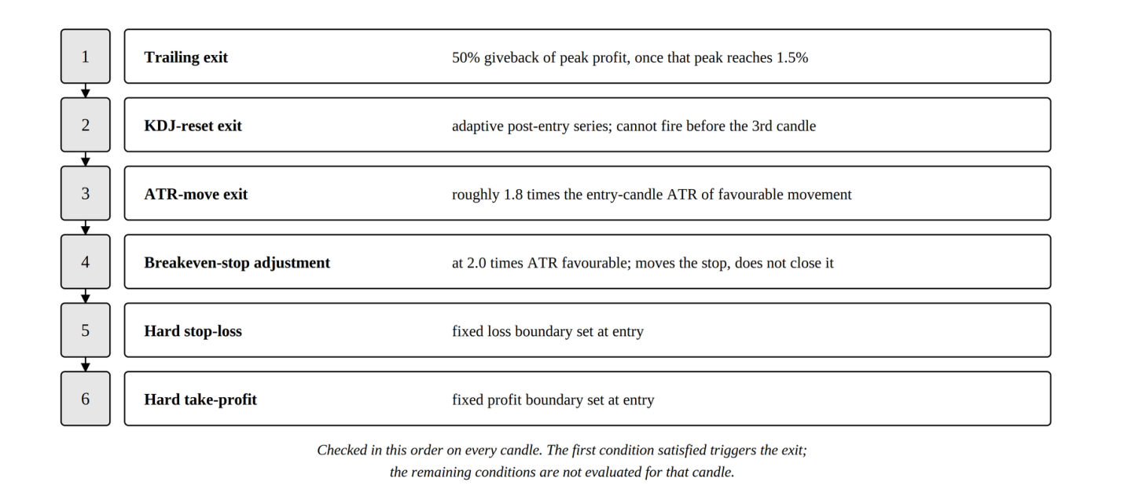
Time-scaled 1-hour version (1-hour test in SOP 3 only). An hour is a quarter of a 4-hour candle, so the time-scaled version multiplies every window counted in candles by four to cover the same clock time: MACD (48, 104, 36), a KDJ window of 36, ATR windows of 56 and 800, pivot lookbacks of 20 and 200, and an Order Block expiry of 2,000 candles. Pattern shapes and price thresholds are not windows and stay as in Table 1: the two-candle MACD rise, the three-candle K-acceleration and its range, the stop-loss and reward-to-risk minimums, the exit multiples, and the Order Block quality windows. The literal version changes nothing, so each window covers a quarter of its 4-hour clock time.

E. Portfolio Construction and Contribution Schedule
This section gives the full construction of every comparison arm, so Tables 10 to 13 can be rebuilt by hand.
Shared timing rule. A contribution lands on the first bar of every ISO calendar week and buys at that bar's close. The blended model and the head-to-head averaging arm both use this rule, so they cannot drift apart. The primary window holds 210 such weeks; the 2018 to 2022 window holds 209.
Head-to-head arms. Each starts from $10,000. The strategy arm holds the full amount in cash from the first bar. While a trade is open, its value is marked to market at every candle close: the value at entry times one plus the trade's percentage move since entry, with the sign flipped for a short. At the exit candle this equals the booked return, so marking changes no final value. Each trade commits the full amount, unlevered and never partly sized. Trades are modelled as BTCUSDT USDT-M perpetual futures, a contract that tracks Bitcoin's price with no expiry date, at 1x (no borrowed money). This lets the strategy go short, betting on a fall, as well as long (12 of the 27 trades are shorts), which a spot account cannot do, and its cost model uses the Binance USDT-M Futures taker fee. Between trades the arm sits in cash earning nothing.
The weekly averaging arm contributes $10,000 ÷ 210 = $47.6190 per week ($10,000 ÷ 209 = $47.8469 in the 2018 window), each buying at that bar's close. Its value at any bar is units held times the current close. Returns exclude any contribution made in the same period, so new money is never counted as return:
$r_{k} = \left(V_{k} − C_{k}\right) / V_{k−1} − 1$
Here V_k is the arm's value at the k-th daily close and C_k is the contribution since the previous daily close, which is zero on six days in seven. The lump-sum arm buys the full $10,000 at the first bar's opening price, not its close, and holds to the last bar's close.
One clock for Sharpe and drawdown. Every arm in Tables 10 to 13 is valued at each daily close (the last 4-hour candle of each UTC day), and daily returns are annualized with m = 365, since Bitcoin trades every day. One clock is needed because on 4-hour candles most strategy returns are zeros from idle cash, while the averaging arm changes only weekly, so ratios at each arm's own frequency are not comparable. Maximum drawdown uses the same daily values for every arm and blend, so the strategy's open trades count toward its drawdown. On this clock the averaging arm's worst fall, −36.02%, came in June 2022, after only 25 weekly contributions, when its small balance fell with Bitcoin. Sampled only at its weekly contribution candles, as in earlier drafts, its worst fall was −27.85%, in late 2025.
One reconciliation applies wherever the strategy arm appears. Its Total return column is the simple sum of trade returns, the convention behind the +30.31% headline. Its Final capital column compounds the same returns in order from $10,000: +34.18%, which gives $13,417.77. The passive arms hold one position throughout, so they have no such gap.
In the net-of-cost Table 11, the strategy arm pays a 0.20% round-trip cost off each trade's return, and the passive arms pay a 0.10% one-sided markup on the buy price, since they buy and hold.
Blended-sleeve model. Contributions are 1.0 relative unit per week across 210 weeks, not dollars, so Table 13 has no dollar column and should not be read against the $10,000 used elsewhere. In the 100% / 0% baseline the full unit buys Bitcoin at that bar's close. At a strategy share f of 0.10, 0.20, or 0.30, the rest buys Bitcoin and f goes into a strategy sleeve. The sleeve's cash enters each trade at its entry candle and is marked to market while the trade is open, as in the strategy arm. A contribution that arrives during a trade waits as cash until the trade exits, and the sleeve is never moved back into Bitcoin. In the cash control, the same share f is held as cash earning nothing. Portfolio value at any daily close is Bitcoin units times the close, plus the sleeve. Sharpe uses that value at every daily close, net of that day's contribution, annualized with m = 365; maximum drawdown uses the same daily values and includes principal. Table 13 is net of costs (0.20% off every strategy trade, a 0.10% markup on every Bitcoin purchase), with gross rows as a sensitivity check.
Table 13's net 100% / 0% row and Table 11's Weekly DCA row give the same Sharpe of 0.555 and the same maximum drawdown of −36.02%, and its gross row matches Table 10's 0.558 and −36.02%, because all of them use the same weekly rule. The tables meeting at their shared point is a free consistency check.

F. Data Analysis
The main approach is exploratory data analysis (Tukey, 1977): descriptive statistics, distribution summaries, and table comparisons, used to find patterns before drawing conclusions. It suits a finite, fully observed set of trade records with no missing values. The descriptive statistics are trade count, win rate, net return, average return, and standard deviation.
Statistical Software and the Division Between Library and Custom Code
All statistics were computed in Python 3 with SciPy, a free open-source library used across published quantitative research (Virtanen et al., 2020). The standard tests are library code, not this study's own, which rules out a whole class of arithmetic errors.
This paper uses nine core statistical procedures (Table 2). Three are unmodified SciPy calls. Six are formulas written for this study, because no single library function computes them or because they follow this study's resampling design. Sharpe and maximum drawdown are descriptive measures, not tests, and carry no p-value anywhere in this paper.
Table 2
Division Between SciPy Library Calls and Formulas Written for This Study
Quantity | Source | Routine
Exact binomial test on win rate | SciPy | scipy.stats.binomtest
Pearson’s correlation and its p-value | SciPy | scipy.stats.pearsonr
Spearman’s correlation and its p-value | SciPy | scipy.stats.spearmanr
Bootstrap confidence interval on total return | Custom | Percentile bootstrap, Formula 1
Maximum drawdown | Custom | Running-peak decline, Formula 2
Sharpe ratio | Custom | Annualized risk-adjusted return, Formula 3
Stationary block bootstrap p-value and interval on average return (SOP 3, 1-hour test; SOP 1 after-cost check) | Custom | Formula 4
Bootstrap difference in average return between two trade sets (SOP 3, gate comparison) | Custom | Formula 5
Holm adjustment for nine simultaneous tests (SOP 3, gate comparison) | Custom | Formula 6
Note. Formula numbering runs 1 to 6. Appendix B gives each custom formula in source form.
Tests Computed by SciPy
One-sided exact binomial test. With n closed trades and w winners, and a null win probability of 0.5, the one-sided p-value is the sum, for k from w to n, of n-choose-k times 0.5 to the power n:
$p_{one−sided} = \sum_{k=w}^{n}{}C(n, k) {(0.5)}^{k} {(0.5)}^{n−k} = \sum_{k=w}^{n}{}C(n, k) {(0.5)}^{n}$
Here the p-value is the chance of 19 or more wins out of 27 if each trade were a fair coin flip. Win rate alone is not edge: a strategy can win often and still lose money if its losses are larger, so average return per trade is reported beside it. The test is one-sided because the hypothesis is directional; two-sided values are given for reference.
Correlation. Pearson's r and Spearman's ρ were computed between holding time, in candles, and percentage return. Pearson assumes a straight-line relationship; Spearman assumes only a consistent direction.
Formulas Written for This Study
Formula 1. Percentile bootstrap confidence interval. Let r₁, r₂, …, r_n be the percentage returns of the n trades. For each of B repetitions, draw n returns from that set at random with replacement and record the resample's total and mean:
$T^{(b)} = \sum_{i=1}^{n}{}{r_{i}}^{(b)}$
${\bar{T}}^{(b)} = \frac{1}{n} × \sum_{i=1}^{n}{}{r_{i}}^{(b)}, b = 1, 2, …, B$
The 95% confidence interval is the 2.5th and 97.5th percentiles of the B recorded values:
${CI}_{95\%} = \left[Q_{2.5}\left(T^{(1)}, …, T^{(B)}\right) , Q_{97.5}\left(T^{(1)}, …, T^{(B)}\right)\right]$
Twenty-seven trades are too few, and too skewed by a few large winners, for a normal-theory interval. The bootstrap uses the data's own shape instead of assuming one (Efron & Tibshirani, 1993). Drawing exactly n values with replacement follows Efron, so the spread reflects sampling uncertainty, not a changed sample size. The parameters are B = 10,000, n = 27, and a fixed seed of 42, so the figure is exactly reproducible. This is the plain percentile bootstrap, by choice, not the bias-corrected and accelerated version.
Formula 2. Maximum drawdown. Let E_t be the value of an equity curve at time t. Define the running peak, the percentage decline from that peak, and the worst such decline:
$P_{t} = \max_{u ≤ t} E_{u}$
${DD}_{t} = \left[\frac{E_{t} − P_{t}}{P_{t}}\right] × 100$
$MDD = \min_{t} {DD}_{t}$
Drawdown is a percentage, not dollars, so arms with very different equity curves can be compared directly. Tracking the running peak, rather than comparing only the final value with the all-time high, catches a fall partway through that later recovers.
Formula 3. Sharpe ratio. Let R₁, R₂, …, R_N be an arm's per-period returns, R̄ their mean, s_R their standard deviation, and m the number of periods in a year; every arm in this paper uses daily returns, so m = 365:
$SR = \left(\frac{\bar{R}}{s_{R}}\right) × \sqrt{m}$
The Sharpe ratio measures return per unit of variability, so a higher value means a smoother ride for the same return (Sharpe, 1994). It is computed here with the risk-free rate set to zero.
Formula 4. Stationary block bootstrap. Trades that follow each other can share the same market mood, so drawing them one at a time, as Formula 1 does, can understate the uncertainty. The stationary bootstrap (Politis & Romano, 1994) instead copies runs of consecutive trades. Starting from a random trade, each next draw continues the current run with probability 1 − 1/L or jumps to a new random trade with probability 1/L, wrapping from the last trade back to the first, until n returns are drawn. L, the expected run length, is n^(1/3) rounded, which gives L = 3 for 31 trades. With B = 10,000 resamples and seed 20260808, the bootstrap one-sided p (percentile method) is the share of resample means at or below zero, and the 95% interval is the 2.5th and 97.5th percentiles of those means. It is used for the pre-registered 1-hour test and, with seed 42, for the after-cost check on the 27 four-hour trades in SOP 1, where L = 3 as well.
Formula 5. Bootstrap difference in average return. Each gate setting trades a different set of trades from the full rule, so the two sets cannot be paired. For each of B = 2,000 repetitions, one resample is drawn with replacement from each set at its own size, and the difference between the two resample means is recorded. The 95% interval is the 2.5th and 97.5th percentiles of those differences. The two-sided p-value is twice the smaller of the shares of differences at or below zero and at or above zero, capped at 1. The two sets share many of the same trades, so treating them as independent overstates the noise in the difference. That makes the test conservative: it can miss a real difference but is unlikely to invent one.
Formula 6. Holm adjustment. Sort the m = 9 raw p-values from smallest to largest, p₍₁₎ ≤ … ≤ p₍ₘ₎. The adjusted value for the i-th is the largest of (m − j + 1) × p₍ⱼ₎ over every j up to i, capped at 1. The smallest p-value is multiplied by 9, the next by 8, and so on, and an adjusted value is never allowed to fall below the one before it (Holm, 1979). A result counts as significant only if its adjusted value is below 0.05.
Additional analyses. The headline result was recomputed under six cost scenarios and rerun with the stop-loss checked against each candle's high and low instead of its close (Table 5). Every arm in the passive comparison was valued at daily closes, with the strategy's open trades marked to market (Section E), compared gross and net of fees, and rerun on data that came after the code was finished. The binomial test is rerun in full on each fee-adjusted trade set, not adjusted from the gross p-value. Both follow-up analyses use a single-trade simulator that runs the same exit rules from any entry candle; with all four gates on, it reproduces all 27 baseline trades exactly, and on 1-hour data it reproduces every trade the main engine makes.
Reproducibility. A golden-master regression harness recomputes the indicators and the full simulation from raw candles and requires exact agreement with committed reference files: indicators to within 10⁻⁶ and all 27 trade records exactly. It runs after every code change. Truncation testing on the ATR(14), ATR(200), and fixed KDJ(9,3,3) series passed 180 of 180 sampled checks: each indicator recomputed on a shortened dataset gave the same values, as it must if no future data is used. The separate JavaScript dashboard cross-checks the indicators and entry conditions. All results are reported as observed, including non-significant and unfavourable ones.

Findings
This section follows the three research questions. Each subsection opens with a direct answer, then gives the evidence; interpretation is left to the Conclusions. Appendix A traces every number to the function that produced it, and Appendix D shows how to recompute by hand every number that can be.

Answers to SOP 1 and Hypothesis H₁
Note. The research questions are stated on page 13, under Statement of the Problem.
Answer: yes before costs, no after them. The strategy won 70.37% of 27 trades for a +30.31% total return before costs, at p = 0.0261. A realistic 0.20% round-trip cost moves p to 0.1239, so H₁ is not supported once real trading costs are charged, which at this sample size is inconclusive. After costs the total return is still positive, +24.91%, but the bootstrap interval that allows for runs of related trades reaches below zero. Checking stops against candle highs and lows instead of closes moves p to 0.0610 even before costs.
Table 3
Baseline Strategy Performance, 2022 to 2026 Window, Gross of Costs
Metric | Value
Trades | 27
Wins / Losses | 19 / 8
Win rate | 70.37%
Total return, before costs | +30.31%
Average return per trade | +1.1225%
Standard deviation of return per trade | 2.41%
One-sided binomial p | 0.0261
Two-sided binomial p | 0.0522
Note. Exact binomial test on 27 trades with 19 wins against a null win probability of 0.5.
With 27 trades and 19 wins, the one-sided exact binomial test gives
$P\left(K ≥ 19 ; n = 27, p = 0.5\right) = \sum_{k=19}^{27}{}C(27, k) {(0.5)}^{27} = 0.0261$
If every trade were a fair coin flip, 19 or more wins out of 27 would happen about 26 times in 1,000. Each trade is named by the candle index where it was entered: 335, 359, 673, 902, 1050, 1158, 1913, 2624, 2859, 3100, 3196, 3859, 3947, 4455, 5800, 5825, 6040, 6109, 6366, 6537, 6991, 7109, 7938, 7964, 8188, 8280, and 8596. Appendix C gives the full record of each trade.
Bootstrap interval. A bootstrap of 10,000 resamples of size 27, with a fixed seed of 42, gives a point estimate of +30.31% total return, the observed sum of the 27 returns. (Appendix C prints each return to four decimals, so its rows add to +30.3064%; the unrounded sum is +30.3065%.) The 95% confidence interval is [+5.99%, +54.99%]: wide, but it excludes zero, and 99.25% of resampled totals were positive. For average return per trade the interval is [+0.22%, +2.04%]. The companion website recomputes the bootstrap in the browser at 2,000 resamples and gets [+7.48%, +54.46%]. It is separate TypeScript code with its own random number generator, and the gap was traced to the resample count alone. The two are kept separate because the website's independence is what makes the cross-check useful.
After costs. The same bootstrap on the 27 returns after a 0.20% round-trip cost gives a 95% interval on total return of [+0.59%, +49.59%], with 2.27% of resampled totals at or below zero. That method draws trades one at a time, as if they were unrelated. Trades close in time can share the same market mood, so the after-cost returns were also resampled in runs of consecutive trades with the stationary block bootstrap (Formula 4, L = 3, seed 42). That gives [−1.29%, +49.96%] on total return and [−0.05%, +1.85%] on average return per trade, with 3.20% of totals at or below zero, so the interval includes zero. Before costs the same block bootstrap gives [+4.11%, +55.36%], which excludes it. The return is therefore positive before costs, but after a 0.20% round trip it cannot be separated from zero once related trades are allowed for.
Cost sensitivity. Six scenarios were run: gross, fee-only, and four from 0.14% to 0.40% round trip. The confirmed Binance USDT-M Futures standard taker fee is 0.05% per side, or 0.10% per round trip, and slippage was modelled separately at 0.05% per side, which may be optimistic for stop-loss exits in fast candles.
Table 4
Win Rate and Significance Across Six Transaction-Cost Scenarios
Round-trip cost | Wins (of 27) | Win rate | Total net return | p (one-sided) | Significant at .05?
0.00% (none) | 19 | 70.37% | +30.31% | 0.0261 | Yes
0.10% (fee only) | 19 | 70.37% | +27.61% | 0.0261 | Yes
0.14% | 17 | 62.96% | +26.53% | 0.1239 | No
0.20% (primary) | 17 | 62.96% | +24.91% | 0.1239 | No
0.24% | 17 | 62.96% | +23.83% | 0.1239 | No
0.40% | 15 | 55.56% | +19.51% | 0.3506 | No
Note. Round-trip cost is the total fee and slippage paid on one trade, entry plus exit, and is subtracted from each of the 27 trade returns. A trade counts as a win only if its return after that cost is above zero. Costs therefore turn small winners into losers, which is why the win rate falls as cost rises: trades 7938 and 8188 become losses from 0.14% upward, and trades 2859 and 5825 also become losses at 0.40%. Each row re-runs the one-sided binomial test against a 50% win rate.
Figure 6
Win Rate and Significance Across Six Transaction-Cost Scenarios
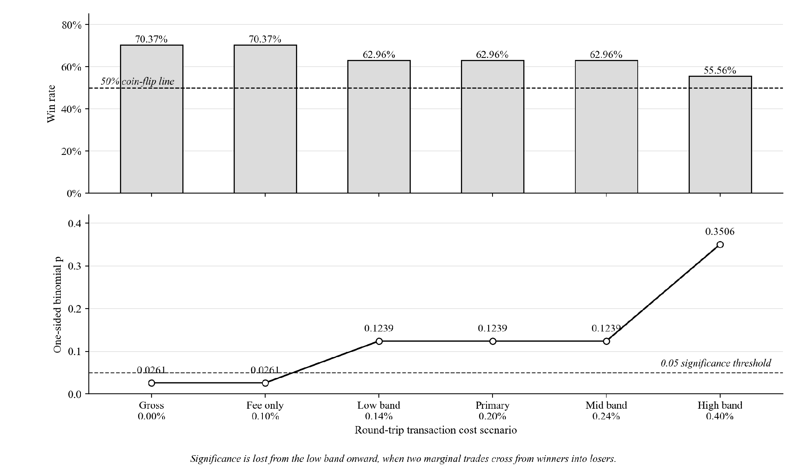
The flip, shown in Figure 6, comes from exactly two trades, 7938 and 8188, worth +0.12% and +0.13% before costs, turning from winners into losers. The smallest winner, trade 7938, earned +0.1196%, so the win rate stays significant only while the total round-trip cost is below about 0.12%.
Funding. Perpetual futures also charge or pay a funding rate every eight hours, which the cost scenarios leave out. From Binance's published BTCUSDT funding history, the 27 trades were open across 114 funding settlements. Long trades paid 0.175 percentage points and short trades received 0.287, a net credit of 0.112 points. With the 0.20% round-trip cost and funding together, total return is +25.02% instead of +24.91%, wins stay at 17 of 27, and p stays at 0.1239. No single trade's funding exceeded 0.06%, so funding changes no result in this paper.
Stop-loss check. The engine checks the stop-loss only at each candle's close (Section D). Table 5 reruns the same 27 entries with the stop checked against each candle's high and low, filled at the stop price, or at the candle's open if price gapped through it. Every other exit rule is unchanged, so only the stop can change and the trade set stays at 27. Six trades change. Trade 902 turns from a +3.22% winner into a −1.61% loser, because price touched its stop inside a candle before the move that closed it as a winner. Trades 335 and 3196 lose more (−2.31% and −1.82% instead of −0.66% and −0.78%). Trade 2624 loses less (−2.68% at its stop instead of −4.65% at the close), and trades 3947 and 6109 change by less than 0.1 points. With high-low stops the strategy wins 18 of 27 before costs, +24.85% in total, at p = 0.0610, so the win rate is no longer significant even before costs. After the 0.20% cost it wins 16, +19.45%, at p = 0.2210. The close-based stop therefore flatters the reported win rate.
Table 5
Stop-Loss Check at Candle Close Versus Candle High and Low
Stop checked at | Round-trip cost | Wins (of 27) | Win rate | Total return | p (one-sided)
Close (as reported) | 0.00% | 19 | 70.37% | +30.31% | 0.0261
Close (as reported) | 0.20% | 17 | 62.96% | +24.91% | 0.1239
High and low | 0.00% | 18 | 66.67% | +24.85% | 0.0610
High and low | 0.20% | 16 | 59.26% | +19.45% | 0.2210
Note. Only the stop-loss check changes. Entries and every other exit rule are as in the baseline, so the trade set stays at the same 27 entries. A stop touched inside a candle is filled at the stop price, or at the candle's open if price opened beyond the stop. Prices are Binance spot candles, as everywhere in this paper. Each row re-runs the one-sided binomial test against a 50% win rate.
Regime dependence. Trades were tagged by market condition at entry using two independent methods. The first is a calendar split. The second measures how far price sat below its previous all-time high, starting from Bitcoin's pre-window high of $69,000 on 2021-11-10: bear at 40% or more below, sideways between 40% and 12% below, and bull less than 12% below.
Table 6
Performance by Calendar Regime
Regime | Trades | Win rate | Return contribution | Share of total return
Bear (2022) | 7 | 57.14% | +10.45% | +34.5%
Chop (2023) | 6 | 50.00% | −5.39% | −17.8%
Bull (2024 to 2025) | 14 | 85.71% | +25.25% | +83.3%
Note. The three rows partition the same 27 trades, so counts sum to 27 and contributions sum to +30.31%.
Table 7
Performance by Drawdown-From-High Regime
Regime | Trades | Win rate | Return contribution | Share of total return
Bear (at or below −40% from high) | 12 | 50.00% | −1.63% | −5.4%
Chop (−40% to −12% from high) | 8 | 87.50% | +18.89% | +62.3%
Bull (above −12% from high) | 7 | 85.71% | +13.05% | +43.1%
Note. The same 27 trades, re-partitioned by a different definition of market regime.
The two methods agree on only 13 of the 27 trades, because they measure different things: much of 2023 sat 57% to 64% below the all-time high even though price that year moved sideways rather than falling. Both agree that bull is the strongest regime, at an 85.71% win rate under each.
Holding time and return. Across the 27 trades, Pearson's r = +0.4907 (t = 2.82, df = 25, p ≈ 0.0094) and Spearman's ρ = +0.4797 (p ≈ 0.0113): trades held longer tended to end larger. Pearson's r is significant at the 1% level, Spearman's ρ at the 5% level only. The link largely reflects the exit design, since stops cut losers early while winners run, so it is descriptive, not evidence of a separate effect.
Forward test. A forward out-of-sample test used 4-hour data from 2026-01-01 to 2026-07-31, after every change to the strategy code, run through the same frozen pipeline after first confirming that the locked 27-trade baseline reproduced exactly.
Table 8
Forward Out-of-Sample Result, January to July 2026
Metric | Value
New out-of-sample trades | 4
Wins / Losses | 1 / 3
Win rate | 25.00%
Total return | −3.45%
Average return per trade | −0.86%
Note. Same frozen pipeline as Table 3, applied to candles after 2026-01-01 08:00:00.
This is reported as it came out: small and unfavourable. If the true win rate were the 70.37% seen in 2022 to 2026, one win or fewer in four trades would still happen about 8% of the time (p = 0.081), so four trades cannot show that the edge has gone either. A separate eight-year backfill check ran the same pipeline on data extended back to 2018-01-01, to see whether four extra years of indicator warm-up would change the locked results. All 27 locked trades matched by entry timestamp, with a maximum profit-and-loss difference of 0.0000000000%.
Table 9
Comparison of the Formulation Window, the Primary Window, and Their Combination
Window | N | Win rate | Total return | Avg return/trade | Binomial p (1-sided)
2018-01 to 2022-01, formulation period, not out-of-sample | 25 | 60.00% | +21.82% | +0.87% | 0.2122
2022-01 to 2026-01, primary reported window | 27 | 70.37% | +30.31% | +1.12% | 0.0261
Combined 2018 to 2026, mixed provenance | 56 | 62.50% | +48.68% | n/a | 0.0407
Note. Each row is a separate binomial test. The combined row is the 25 formulation trades, the 27 primary trades, and the 4 forward-test trades: 25 + 27 + 4 = 56, and 15 + 19 + 1 = 35 wins.
The combined row should never be cited alone, because about half of it comes from the period the rules were built on. The strategy does worse on its own build data, 60.00% at p = 0.2122, than on the primary window.

Answers to SOP 2 and Hypothesis H₂
Note. The research questions are stated on page 13, under Statement of the Problem.
Answer: weekly buying won on final value by a wide margin, and the strategy won on risk-adjusted shape while holding a position only 2.63% of the time. Both are true, and neither settles the comparison alone. Putting part of a weekly plan into the strategy, rather than replacing the plan, improved its risk-adjusted profile after costs at every share tested and beat holding the same share as cash on both measures, which supports H₂ (Table 13). The margin over cash is small.
Table 10
Three-Arm Head-to-Head Comparison, 2022 to 2026, Gross of Costs
Arm | Total return | Final capital from $10,000 | Sharpe (daily) | Max drawdown (daily) | Time in market
Combined strategy | +30.31%ª | $13,417.77 | 1.1440 | −6.64% | 2.63%
Weekly DCA into BTC | +123.13% | $22,312.94 | 0.5581 | −36.02% | 100.00%
Lump-sum buy-and-hold | +90.07% | $19,007.32 | 0.5534 | −66.93% | 100.00%
Note. Sharpe and maximum drawdown use each arm's value at every daily close, with the strategy's open trades marked to market; Sharpe is annualized with m = 365 (Section E). The weekly arm's value is measured at its last contribution candle, 2025-12-29. Time in market for the strategy is 2.6349% of candles. The summed-versus-compounded reconciliation for the strategy arm is set out in Section E. The combined strategy is the MACD, KDJ, ATR, and Smart Money Concepts strategy tested in this study. ªSimple sum of the 27 trade returns, the headline figure used throughout this paper. Compounding the same returns in sequence gives +34.18%, which produces the $13,417.77 final capital.
Figure 7
Three Arms Grown From an Equal $10,000 Start, 2022 to 2026
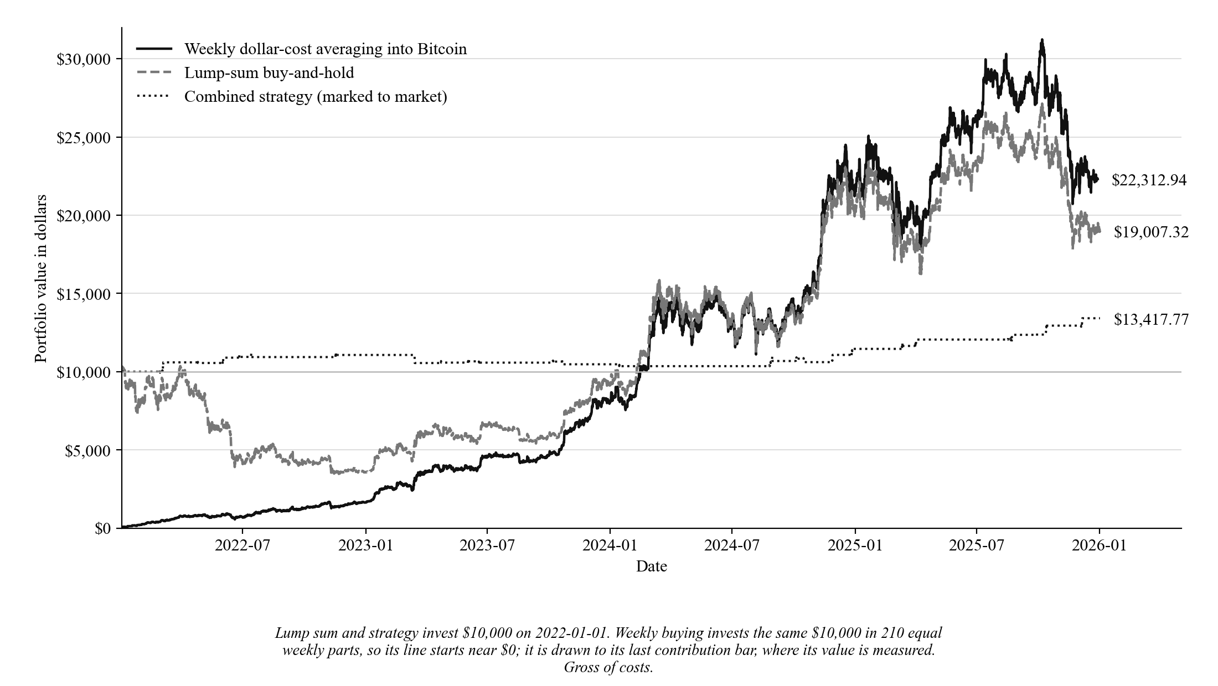
Table 11
Three-Arm Head-to-Head Comparison, 2022 to 2026, Net of Costs
Arm | Total return | Final capital from $10,000 | Sharpe (daily) | Max drawdown (daily) | Time in market
Combined strategy | +24.91%ª | $12,719.01 | 0.9456 | −8.13% | 2.63%
Weekly DCA into BTC | +122.91% | $22,290.65 | 0.5552 | −36.02% | 100.00%
Lump-sum buy-and-hold | +89.88% | $18,988.34 | 0.5534 | −66.93% | 100.00%
Note. Same construction and window as Table 10, with costs applied as set out in Section E. Both passive arms are almost unaffected, because a single purchase markup is charged once rather than 27 times. ªSimple sum of the 27 net trade returns. Compounding them in sequence gives +27.19%, which produces the $12,719.01 final capital.
Weekly buying beat the strategy on final value: $22,312.94 against $13,417.77 gross, and $22,290.65 against $12,719.01 after costs (Figure 7). On the same daily clock, the strategy's gross Sharpe of 1.1440 exceeds buy-and-hold's 0.5534 and weekly buying's 0.5581, but it holds a position only 2.63% of the time against 100% for both passive arms, so this is not a like-for-like comparison.
Table 12
Three-Arm Head-to-Head Comparison, 2018 to 2022 Formulation Window, Gross of Costs
Arm | Total return | Final capital from $10,000 | Sharpe (daily) | Max drawdown (daily) | Time in market
Combined strategy | +21.82%ª | $12,282.53 | 0.607 | −8.24% | 1.87%
Weekly DCA into BTC | +439.88% | $53,987.55 | 0.802 | −52.37% | 100.00%
Lump-sum buy-and-hold | +236.96% | $33,696.49 | 0.796 | −81.18% | 100.00%
Note. Same construction as Table 10, applied to 2018-01-01 to 2022-01-01, where the weekly schedule holds 209 contributions of $47.8469. ªSimple sum of the 25 trade returns. Compounding them in sequence gives +22.83%, which produces the $12,282.53 final capital.
That window is where the rules were built, so it is shown for comparison only. Bitcoin's 2018 to 2022 window held a much bigger fall-and-recovery cycle than 2022 to 2026, which favours weekly buying by lowering its average purchase price.
Blended plan. After costs, both risk-adjusted measures improve at every step as the strategy share rises from 0% to 30%, and at every share the strategy sleeve beats the cash sleeve on both Sharpe and drawdown, which is the decision rule set for H₂. The gross rows show the same pattern.
Table 13
Risk-Adjusted Profile of a Blended DCA Plan: Strategy Sleeve Versus Cash Sleeve
Split (BTC-DCA / Strategy) | Sharpe, strategy sleeve | Sharpe, cash sleeve | Max drawdown, strategy sleeve | Max drawdown, cash sleeve
100% / 0%, net | 0.555 | 0.555 | −36.02% | −36.02%
90% / 10%, net | 0.576 | 0.566 | −31.03% | −31.22%
80% / 20%, net | 0.598 | 0.576 | −28.30% | −28.87%
70% / 30%, net | 0.621 | 0.585 | −26.43% | −27.34%
100% / 0%, gross | 0.558 | 0.558 | −36.02% | −36.02%
90% / 10%, gross | 0.581 | 0.569 | −31.02% | −31.22%
80% / 20%, gross | 0.606 | 0.579 | −28.22% | −28.87%
70% / 30%, gross | 0.632 | 0.587 | −26.31% | −27.34%
Note. Net rows charge 0.20% on every strategy trade and a 0.10% markup on every Bitcoin purchase; gross rows charge nothing and are a sensitivity check. The cash sleeve holds the same share as cash earning nothing. Every value is taken at daily closes, with the strategy sleeve's open trades marked to market, over 210 weekly contributions in 2022 to 2026, under the construction in Section E. Maximum drawdown includes principal. The Sharpe ratio assumes a risk-free rate of zero. The table measures how smooth the plan was, not how much money it ended with.
Figure 8
Strategy Sleeve Versus Cash Sleeve Across Increasing Allocations, Net of Costs
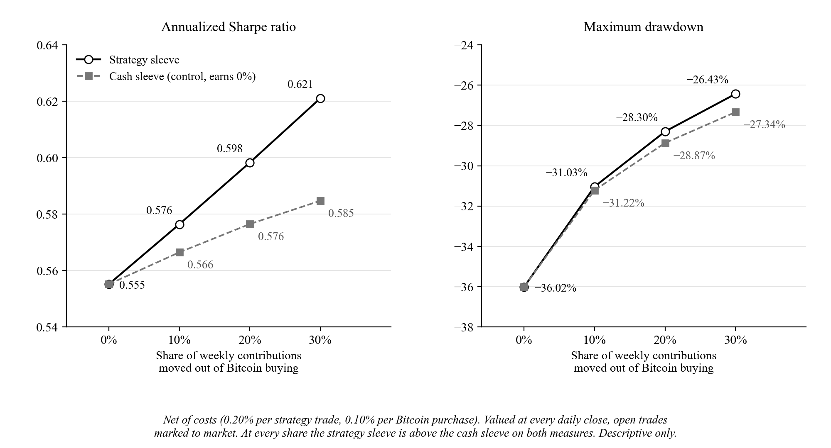
After costs, Sharpe rises from 0.555 to 0.621 and maximum drawdown shallows from −36.02% to −26.43% as the strategy share rises to 30% (Figure 8). Holding the same 30% as cash gives 0.585 and −27.34%, so the strategy sleeve beats cash on both, by 0.036 in Sharpe and 0.90 points in drawdown; at 10% the drawdown margin is only 0.18 points. Most of the drawdown improvement comes from holding part of the plan out of Bitcoin at all. The conclusion has the limits stated with the hypothesis: it rests on one price path, carries no p-value, and shows what a blend would have done over this window, not what it will do over another.

Answers to SOP 3
Note. The research questions are stated on page 13, under Statement of the Problem.
Answer: the gate results point the same way but are not significant. Switching off any one gate lowered average return per trade in both windows, by 0.31 to 0.89 percentage points in 2022 to 2026, but no difference survived the Holm correction, and the 2018 to 2022 agreement is in-sample. Running the same rules on 1-hour candles (after Table 15) did not raise trade count without losing money per trade either.
The entry rule has four indicator gates on top of the Order Block touch: MACD histogram, KDJ, K-acceleration, and ATR regime (Figure 4). The Order Block touch, minimum stop distance, and minimum reward-to-risk stay on in every setting; only gates are switched off, and no threshold changes. Four settings remove one gate each, four keep one gate only, and a ninth adds an Order Block quality filter of at least 1 to the full rule. The ninth is not an indicator, but it was part of the same pre-registered family of nine, so it stays in the Holm correction. With all four gates on, the comparison code reproduces the 27 baseline trades exactly.
Table 14
Effect of Each Indicator Gate, 2022 to 2026 Window, Gross Average per Trade
Gate setting | Trades | Win rate | Avg return per trade | Total return net of 0.20% | Change in avg vs baseline [95% CI] | p (two-sided) | p (Holm)
All four gates (baseline) | 27 | 70.37% | +1.122% | +24.91% | — | — | —
Remove MACD | 73 | 58.90% | +0.236% | +2.65% | −0.886 [−1.97, +0.16] | 0.104 | 0.540
Remove KDJ | 53 | 56.60% | +0.411% | +11.18% | −0.712 [−1.80, +0.31] | 0.166 | 0.664
Remove K-acceleration | 46 | 60.87% | +0.601% | +18.42% | −0.522 [−1.77, +0.71] | 0.427 | 1.000
Remove ATR regime | 35 | 68.57% | +0.813% | +21.45% | −0.310 [−1.49, +0.84] | 0.582 | 1.000
MACD only | 114 | 49.12% | −0.038% | −27.13% | −1.160 [−2.15, −0.10] | 0.032 | 0.224
KDJ only | 170 | 50.59% | −0.099% | −50.75% | −1.221 [−2.27, −0.24] | 0.015 | 0.135
K-acceleration only | 224 | 56.70% | +0.340% | +31.38% | −0.782 [−1.75, +0.13] | 0.090 | 0.540
ATR regime only | 337 | 50.74% | +0.078% | −41.13% | −1.044 [−1.96, −0.13] | 0.023 | 0.184
All four + OB quality ≥ 1 | 25 | 68.00% | +1.132% | +23.31% | +0.010 [−1.31, +1.39] | 0.975 | 1.000
Note. Average return per trade is gross of costs; total return subtracts 0.20% from every trade. The change column is each setting's average minus the baseline's +1.122%, with a 95% interval from Formula 5 (B = 2,000). p (Holm) adjusts the nine p-values together using Formula 6. Each setting trades a different set of trades, one position at a time.
Removing MACD costs the most per trade, 0.886 points, and removing the ATR-regime gate the least, 0.310 points. Keeping one gate only costs 0.782 to 1.221 points. Three single-gate settings (MACD only, KDJ only, and ATR regime only) have intervals that exclude zero, with raw p-values of 0.032, 0.015, and 0.023, but after the Holm correction these become 0.224, 0.135, and 0.184, so none can be separated from chance once nine tests are counted. Adding the Order Block quality filter changes almost nothing: +0.010 points on 25 trades.
Two settings stand out descriptively. K-acceleration alone took 224 trades and returned +31.38% after costs, more than the full rule's +24.91%, but earned only +0.140% per trade against +0.922%, with a maximum drawdown of −45.60% against −7.78% (both measured per candle on realized exits, as in the gate comparison, not on Table 11's daily marked-to-market basis). On the 2018 to 2022 window the same setting lost −118.23% after costs over 250 trades, so the result reversed. Removing the ATR-regime gate gave 35 trades instead of 27, a 68.57% win rate, and +21.45% after costs: the closest to the full rule among gate removals by average return per trade, and also the closest on 2018 to 2022, at 36 trades and +17.66% against the baseline's +16.82%. Neither is a finding; each is a candidate for a future pre-registered test on new data.
Table 15
Effect of Each Indicator Gate, 2018 to 2022 Formulation Window, Gross Average per Trade
Gate setting | Trades | Win rate | Avg return per trade | Total return net of 0.20% | Change in avg vs baseline [95% CI] | p (two-sided) | p (Holm)
All four gates (baseline) | 25 | 60.00% | +0.873% | +16.82% | — | — | —
Remove MACD | 80 | 47.50% | −0.324% | −41.95% | −1.197 [−2.66, +0.26] | 0.106 | 0.848
Remove KDJ | 50 | 54.00% | +0.532% | +16.62% | −0.340 [−1.88, +1.29] | 0.678 | 1.000
Remove K-acceleration | 50 | 56.00% | +0.258% | +2.92% | −0.615 [−2.25, +0.94] | 0.451 | 1.000
Remove ATR regime | 36 | 55.56% | +0.691% | +17.66% | −0.182 [−1.78, +1.42] | 0.877 | 1.000
MACD only | 113 | 48.67% | −0.221% | −47.58% | −1.094 [−2.47, +0.25] | 0.107 | 0.848
KDJ only | 192 | 49.48% | −0.024% | −43.09% | −0.897 [−2.16, +0.47] | 0.194 | 1.000
K-acceleration only | 250 | 50.80% | −0.273% | −118.23% | −1.146 [−2.40, +0.18] | 0.093 | 0.837
ATR regime only | 392 | 50.00% | +0.001% | −77.93% | −0.872 [−2.14, +0.43] | 0.169 | 1.000
All four + OB quality ≥ 1 | 22 | 59.09% | +0.968% | +16.89% | +0.095 [−1.62, +1.86] | 0.894 | 1.000
Note. Same construction as Table 14. The rules were formulated on this window, so it is not out-of-sample for them. The baseline here is the 25 formulation-window trades of Table 9.
Figure 9
Change in Average Return per Trade When Indicator Gates Are Switched Off
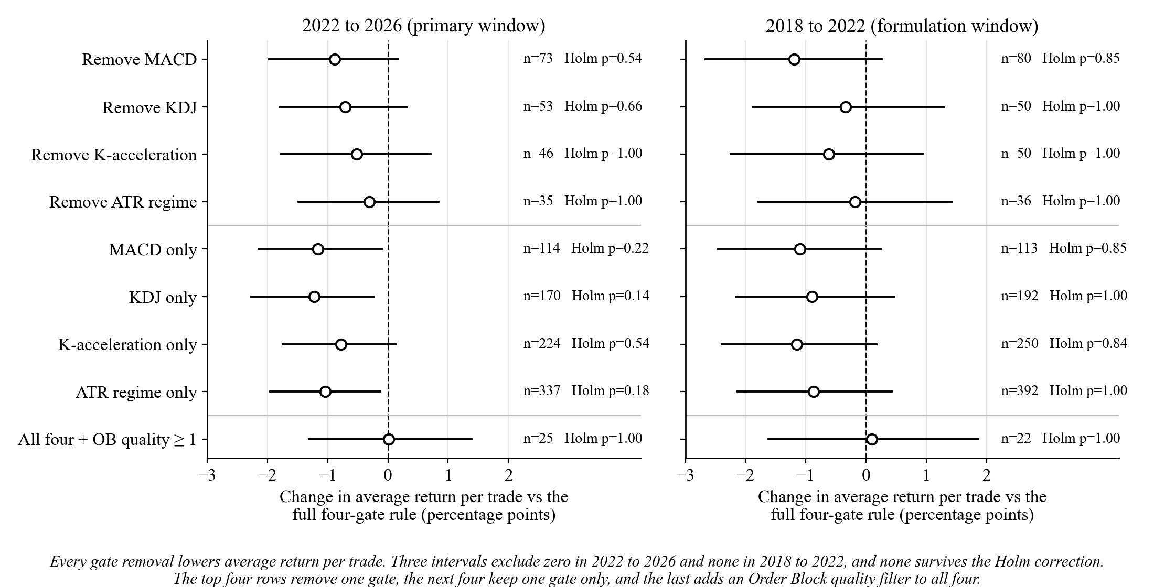
The direction agrees across the two windows (Figure 9): every removal lowers average return per trade in both. The 2018 to 2022 agreement is in-sample, since the rules were set by eye on that window, so it is expected rather than confirming. The sizes do not agree closely, and no 2018 to 2022 interval excludes zero. The nine settings were also run once on January 1 to August 7, 2026, covering the forward test up to the start of the 1-hour holdout, where the full rule made four trades. Every interval there spans zero and every Holm p-value is 1.000, so that run adds nothing either way.
1-hour candles: no. On 1-hour candles the unchanged rules made 31 trades over 2022 to 2026, only four more than on 4-hour candles, and lost an average of 0.179% per trade after costs. The pre-registered one-sided p is 0.696, so the test finds no positive return. The time-scaled version made 14 trades and also lost money per trade.
Table 16
The Same Rules on 4-Hour and 1-Hour Candles, 2022 to 2026
Version | Trades | Trades per year | Win rate | Avg per trade, gross | Avg per trade, net | Total net | 95% CI, avg net | p, avg net > 0 | Binomial p
4-hour (paper) | 27 | 6.75 | 70.37% | +1.122% | +0.922% | +24.91% | [+0.022, +1.837] | — | 0.0261
1-hour literal (primary) | 31 | 7.75 | 41.94% | +0.021% | −0.179% | −5.55% | [−0.834, +0.566] | 0.696 | 0.8595
1-hour time-scaled ×4 | 14 | 3.50 | 57.14% | −0.075% | −0.275% | −3.86% | [−1.174, +0.647] | 0.722 | 0.3953
Note. Net figures subtract a 0.20% round-trip cost from every trade. For the 1-hour rows, the interval and p-value come from Formula 4 (B = 10,000, seed 20260808); the literal row's p is the pre-registered 1-hour test, and the time-scaled row's is descriptive. The 4-hour interval is the paper's Formula 1 interval on average return shifted down by the constant 0.20% cost; resampling the same net returns in runs with Formula 4 (seed 42) gives [−0.048, +1.850] instead. No average-return p-value was pre-registered for it. Binomial p is the one-sided win-rate test of Table 3, counted on gross wins in every row, as in Table 3.
Figure 10
Trade Frequency and Net Return per Trade on 4-Hour and 1-Hour Candles
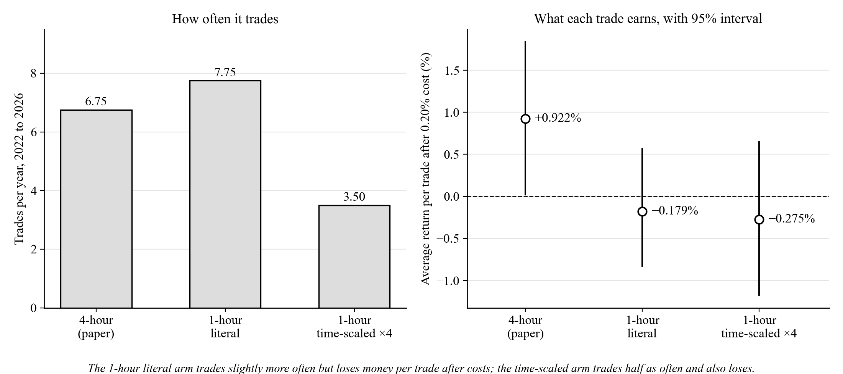
The 1-hour literal version earned 1.101 points less per trade than the 4-hour rules (95% interval [−2.21, −0.002], two-sided p = 0.049; Figure 10). This comparison is descriptive and not corrected for the one beside it: −1.198 points for the time-scaled version, p = 0.096. The literal version's win rate, 41.94%, is below a coin flip (binomial p = 0.8595).
The gates do not help on 1-hour candles. Of 1,570 Order Block touches with a valid stop and reward-to-risk over 2022 to 2026, the four gates let through 49 (3.12%). Picking candidates at random at the same rate, 1,000 times over, matched or beat the gates' average return per trade in 63.3% of runs, and taking every candidate gave 500 trades and −62.71% after costs. On 4-hour candles, removing any one gate lowered return per trade (Tables 14 and 15), though not significantly. The random-selection check was run only on 1-hour candles, so there is no evidence either way on whether the 4-hour gates beat random selection.
The result does not depend on one cost assumption or one stretch of time. At round-trip costs of 0.10%, 0.20%, and 0.30%, the literal version's total is −2.45%, −5.55%, and −8.65%. Across 50 random 12-month windows inside 2022 to 2026, its net total was positive in 8%, and the time-scaled version's in 44%, mostly because that version often made no trade. Both beat buy-and-hold in 16% of windows. The windows overlap heavily, so these shares describe stability, not probabilities.
Table 17
1-Hour Results Outside the Main Window, Including the One-Time Holdout
Window | Version | Trades | Win rate | Avg per trade, net | Total net
2018 to 2022 (formulation) | Literal | 58 | 39.66% | −0.580% | −33.65%
2018 to 2022 (formulation) | Time-scaled | 29 | 55.17% | −0.302% | −8.77%
Jan 1 to Aug 7, 2026 | Literal | 4 | 50.00% | −0.967% | −3.87%
Jan 1 to Aug 7, 2026 | Time-scaled | 5 | 60.00% | +0.141% | +0.71%
Aug 8 to Oct 26, 2026 (holdout) | Literal | 1 | 100.00% | +0.247% | +0.25%
Aug 8 to Oct 26, 2026 (holdout) | Time-scaled | 0 | — | — | +0.00%
Note. Descriptive only. The 2018 to 2022 window is where the rules were formulated. January to August 7, 2026 had already been seen once on 4-hour candles. The holdout ran once, after the main results were committed; Bitcoin rose 23.62% over it.
The holdout produced one literal trade, a long that gained 0.25% after costs, and no time-scaled trade. One trade cannot confirm or contradict anything; it is reported because it was pre-registered. For both versions, the 2018 to 2022 window, where the rules came from, was worse than the main window.
Figure 11 places every 2022 to 2026 gate setting from Table 14 and both 1-hour versions from Table 16 on one chart: trades per year, on a logarithmic axis, against average return per trade after the 0.20% cost. The time-scaled ×4 version is the 1-hour version with every window stretched four times. The only 4-hour setting that trades less often than the baseline, the Order Block quality filter, earns about the same per trade. Every 4-hour setting that trades more often earns less per trade, and five average below +0.15% per trade after costs. The 1-hour literal version trades slightly more often than the baseline and loses money per trade; the time-scaled version trades less often and also loses money. The chart is descriptive: no gate difference survived the Holm correction (Table 14), and the 1-hour points use a different candle interval.
Figure 11
Trade Frequency Against Average Net Return per Trade, 2022 to 2026
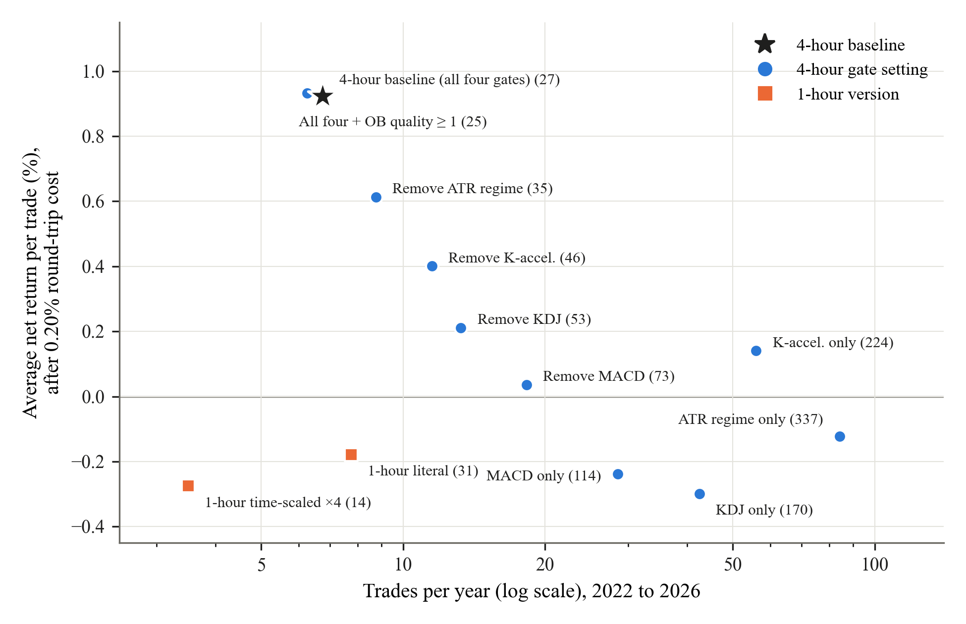

Conclusions
From January 2022 to January 2026 the strategy made 27 trades. It won 70.37% of them and returned +30.31% before costs. Weekly buying still ended with more money from the same capital: $22,312.94 against $13,417.77. These rules are best used as a small part of a weekly buying plan, not in place of one. On this window, the simple habit beat the complicated system.
Returns are positive before costs and uncertain after them. Before costs, the 95% bootstrap interval on total return excludes zero, and 99.25% of 10,000 resamples were positive. After a 0.20% round-trip cost, resampling trades one at a time gives [+0.59%, +49.59%], which excludes zero, but resampling runs of related trades gives [−1.29%, +49.96%], which does not. The win rate is weaker still. It is significant with the exchange fee alone (p = 0.0261), but not once slippage is added (p = 0.1239), and not when stops are checked against candle highs and lows, even before costs (p = 0.0610).
Profit comes from a few trades. Three trades make up 51.7% of the total return, and longer trades earned more, so the big winners were the ones the exit rules let run. The strategy won most often in rising markets (85.71% under both regime methods) and did worse in sideways or falling markets under at least one method.
Against weekly buying, the results point in opposite directions. From equal capital, weekly buying ended with about 1.66 times the strategy's money before costs and 1.75 times after. Valued at daily closes, though, the strategy had the better risk-adjusted return, while invested only 2.63% of the time against 100%. Combining the two works best. After costs, putting 10% to 30% of a weekly plan into the strategy improved both Sharpe and drawdown at every share, and beat holding the same share as cash. The gain over cash is small. At 30%, cash alone cuts the worst drop from −36.02% to −27.34%, and the strategy cuts it only 0.90 points more, to −26.43%. On Sharpe, cash moves the plan from 0.555 to 0.585 and the strategy moves it to 0.621.
The rules did worse on the 2018 to 2022 charts they were built from (Table 9), which suggests the test window really was kept separate. This should not be overstated: choosing rules by eye is weaker than a formal held-out split. The four-trade forward test is the only fully unseen result, and it lost money.
The follow-up analyses help explain why the strategy trades so rarely. Switching off any one gate lowered average return per trade in both windows, but none of the nine differences survived the Holm correction. The only loosened setting that raised total return, K-acceleration alone, had nearly six times the drawdown and failed on the 2018 to 2022 window. The 1-hour version failed its pre-registered test: 31 trades, a loss per trade after costs (one-sided p = 0.696), and gates that chose trades no better than random. The rules seem tied to the 4-hour scale they were built on. These results fit a trade-off between trading often and earning per trade (Figure 11) but do not prove one. With only 27 trades, two marginal trades are enough to move p from 0.0261 to 0.1239.

Limitations
1. Trades are modelled as USDT-M perpetual futures at 1x, unlevered; leverage and margin are not modelled. Funding was estimated from Binance's published rate history (SOP 1), not taken from a live account. Every exit, including the stop-loss, is checked on candle closes, not on price movement inside a candle. That biases the 27 trades: a stop that price touched and then left never fires, and a close far past the stop books a larger loss than a real stop order would. Checking the stop against candle highs and lows (Table 5) lowers the wins from 19 to 18 and moves p to 0.0610 before costs. A leverage model would inherit the same limit. All prices are Binance spot candles standing in for the perpetual contract, which can differ from spot by the basis.
2. The sample is small, 27 trades, and three of them make up 51.7% of the total return, so conclusions in either direction are provisional. At a one-sided 5% level the binomial test needs 19 wins out of 27, and its power to detect a true win rate of 60%, 65%, or 70% is only 0.18, 0.36, or 0.58. A non-significant result at this size is therefore inconclusive, not evidence that no edge exists.
3. The separation between the build period and the reported window is real but weaker than a formal held-out split, and no record exists of what rule variants were tried and dropped.
4. The comparison against passive options is descriptive, not inferential. Sharpe and maximum drawdown are each computed once, on one price path. Formal tests for a difference between Sharpe ratios exist (Ledoit & Wolf, 2008) but were not run, so no confidence interval or p-value attaches to differences between arms or between the strategy and cash sleeves. A different four-year window could reverse the ordering, as Table 12 already shows in one direction.
5. Two choices are disclosed as assumptions, not defended as the only correct ones: Sharpe assumes a risk-free rate of zero, and the bootstrap is the plain percentile form, not the bias-corrected and accelerated version.
6. The strategy trades rarely, about 0.56 trades per month, so forward evidence builds up slowly. Neither attempt in SOP 3 to trade more often kept the return per trade: every gate removal lowered the average, though no difference survived the Holm correction, and the 1-hour version lost money per trade after costs.
7. Structural criteria can read forward unnoticed. Two Order Block criteria originally bounded their search loops by the length of the whole dataset instead of each block's own confirmation candle, so they could read one or two candles not yet available: a real data-leakage bug. A no-lookahead audit found it; the fix bounds both loops at the confirmation candle, with runtime assertions left at those points. It does not change the 27-trade baseline, which applies no quality-score filter. Any study that scans forward from a signal candle can repeat this if the window is not bounded.
8. A reported number can drift from the code that produced it. Two correlation p-values were once reported as below 0.001 when the correct values are about 0.0094 and 0.0113, an overstatement of roughly ten times. Both are corrected here, and Appendix A now traces every number to the function that produced it.
9. Two correct implementations can disagree. The Python bootstrap uses 10,000 resamples and the companion dashboard 2,000, giving different but individually correct intervals. The gap was traced to the resample count alone, by rewriting the dashboard's random number generator in Python and reproducing its interval exactly. Independent reimplementations must be reconciled explicitly, not averaged or dropped.
10. The blended model in Table 13 was corrected in this version. Earlier drafts let a weekly contribution that arrived during an open trade share in that trade's return, although the money was not in the trade when it opened. Contributions now wait as cash until the trade exits. This affects 4 of the 210 contributions and changes the final value of the 70% / 30% gross blend by −0.016 units, from 406.34 to 406.33.
11. The strategy design, code, and statistics were not reviewed by a licensed financial professional or a quantitative-trading practitioner. Verification was internal only, through the regression harness (Appendix A) and the hand recomputation of every headline number (Appendix D).
12. The SOP 3 gate comparison switches gates one at a time, so it can miss effects that appear only when two gates act together. The keep-one-gate settings show part of that, but not every combination was tested. Its p-values are exploratory even after the Holm correction, because the question was asked after the headline result was known.
13. The time-scaled 1-hour version stretches windows only. Pattern shapes such as the two-candle MACD rise and the three-candle K-acceleration stay in candles, so it is only partly the same strategy in clock time. The 1-hour main window is also the same 2022 to 2026 market the 4-hour rules were reported on, and the only fully unseen 1-hour data, the holdout, produced one trade.
14. A machine-learning trade filter was also tested, as the primary test of the same pre-registration as the SOP 3 gate comparison. It did not beat a model trained on shuffled labels (one-sided p = 0.378) and is not a finding of this paper; its full write-up is kept with the code so the test is on record.

Delimitations
1. This study covers one asset only, BTC/USDT. No other cryptocurrency or trading pair was tested.
2. It covers two timeframes: 4-hour candles for every primary result, and 1-hour candles for the pre-registered test in SOP 3. Slower timeframes, and faster ones below 1 hour, were not tested.
3. Three fixed windows were used: January 2018 to January 2022 to build the rules, January 2022 to January 2026 as the primary reported window, and January to July 2026 as a forward test. The 1-hour test in SOP 3 adds a one-time holdout from 2026-08-08 to 2026-10-26. No other split of history was tried.
4. All trades are modelled as USDT-M perpetual futures at 1x, unlevered. No leverage or margin is modelled, and no spot-only version was tested; a spot account could not take the 12 short trades.
5. All price data comes from Binance. No other exchange's order book or price feed was used or cross-checked. Binance spot BTCUSDT candles stand in for the perpetual futures contract the strategy is modelled as trading.
6. The indicator set is fixed at MACD, KDJ, ATR, and Smart Money Concepts Order Blocks. No other technical or on-chain indicator was considered or tested.
7. The passive benchmarks are limited to weekly dollar-cost averaging and a single lump-sum buy-and-hold. No comparison is made to other active strategies, managed funds, or professional traders.
8. This is a backtest and a short forward test only. No capital was ever placed in a live or paper trading account.

Summary and Conclusion
Before costs, a bootstrap of 10,000 resamples put the 95% interval on total return at [+5.99%, +54.99%], which excludes zero. After a 0.20% round-trip cost it is [+0.59%, +49.59%] when trades are resampled one at a time and [−1.29%, +49.96%] when runs of related trades are resampled, so the return is positive before costs but cannot be separated from zero after them. The win rate's significance does not survive either: the realistic 0.20% cost moves p from 0.0261 to 0.1239, through exactly two marginal trades, and checking stops against candle highs and lows moves it to 0.0610 even before costs. H₁ is therefore not supported once real costs are charged, which at 27 trades is inconclusive rather than proof that no edge exists.
On the second question, weekly buying beat the strategy on final value from equal capital, while the strategy had the better risk-adjusted shape at 2.63% time in market against 100%. Inside a weekly buying plan, after costs, both risk-adjusted measures improved at every strategy share from 10% to 30%, and at every share the strategy sleeve beat the same share held as cash on both, so H₂ is supported, descriptively and with no p-value. The margin over cash is small, especially for drawdown. The forward test, run after every change to the code, returned −3.45% over four trades: too few to settle anything, but the only evidence unseen in both senses.
The third question asked, through two pre-registered follow-up analyses, whether the strategy could trade more often. Switching off any one gate lowered average return per trade in both windows, with no difference surviving the Holm correction. On 1-hour candles the unchanged rules made 31 trades and lost 0.179% per trade after costs (one-sided p = 0.696), and their gates picked trades no better than chance. These results fit a trade-off between trade frequency and return per trade without establishing one, and the small sample of 27 trades is the main reason the win-rate result is fragile.
This is a research report, not investment advice, and cryptocurrency carries a high risk of loss. In the Philippines, crypto platforms are regulated by the Bangko Sentral ng Pilipinas and the Securities and Exchange Commission. The study tested whether fixed, published rules beat simple saving and found that they did not, the opposite of a get-rich claim.
In short, this rule set's trades were profitable before costs on this window; after a 0.20% round trip, their return cannot be separated from zero once related trades are allowed for; the win rate's significance depends on costs and on how stops are checked; and wins came more often in rising markets. The study does not show that the strategy will stay profitable, and the only forward evidence so far is unfavourable. Future work should keep collecting forward trades at the strategy's natural pace, since only forward evidence can show whether the edge lasts, and should test the same rules on other instruments. Because the 1-hour test failed, any further timeframe should be pre-registered and tested on candles after 2026-10-26, since no unseen data before that date remains.

References
Arena, C. M. R., Batac, A. A. S., Religioso, A. M. A., Magbata, E. V. S., & Mandigma, M. B. S. (2023). Influences on the stock market investing of tertiary students in the National Capital Region, Philippines. Review of Integrative Business and Economics Research, 12(2), 148–166.
Bangko Sentral ng Pilipinas. (2021). Guidelines for virtual asset service providers (Circular No. 1108, Series of 2021). https://www.bsp.gov.ph/Regulations/Issuances/2021/1108.pdf
Bangko Sentral ng Pilipinas. (2022). 2021 financial inclusion survey: Topline report. https://www.bsp.gov.ph/Inclusive%20Finance/Financial%20Inclusion%20Reports%20and%20Publications/2021/2021FISToplineReport.pdf
Bessembinder, H., Panayides, M., & Venkataraman, K. (2009). Hidden liquidity: An analysis of order exposure strategies in electronic stock markets. Journal of Financial Economics, 94(3), 361–383. https://doi.org/10.1016/j.jfineco.2009.02.001
Biais, B., Glosten, L., & Spatt, C. (2005). Market microstructure: A survey of microfoundations, empirical results, and policy implications. Journal of Financial Markets, 8(2), 217–264. https://doi.org/10.1016/j.finmar.2004.11.001
Chong, T. T.-L., & Ng, W.-K. (2008). Technical analysis and the London stock exchange: Testing the MACD and RSI rules using the FT30. Applied Economics Letters, 15(14), 1111–1114. https://doi.org/10.1080/13504850600993598
Constantinides, G. M. (1979). A note on the suboptimality of dollar-cost averaging as an investment policy. Journal of Financial and Quantitative Analysis, 14(2), 443–450. https://doi.org/10.2307/2330513
Corbet, S., Eraslan, V., Lucey, B., & Şensoy, A. (2019). The effectiveness of technical trading rules in cryptocurrency markets. Finance Research Letters, 31, 32–37. https://doi.org/10.1016/j.frl.2019.04.027
Dai, Z., Dong, X., Kang, J., & Hong, L. (2020). Forecasting stock market returns: New technical indicators and two-step economic constraint method. The North American Journal of Economics and Finance, 53, Article 101216. https://doi.org/10.1016/j.najef.2020.101216
Demirgüç-Kunt, A., Klapper, L., Singer, D., & Ansar, S. (2022). The Global Findex Database 2021: Financial inclusion, digital payments, and resilience in the age of COVID-19. World Bank. https://doi.org/10.1596/978-1-4648-1897-4
Efron, B., & Tibshirani, R. J. (1993). An introduction to the bootstrap. Chapman & Hall.
Fang, J., Jacobsen, B., & Qin, Y. (2014). Predictability of the simple technical trading rules: An out-of-sample test. Review of Financial Economics, 23(1), 30–45. https://doi.org/10.1016/j.rfe.2013.05.004
Finlay, M., & Zorn, J. (2023). Cost averaging: Invest now or temporarily hold your cash? Vanguard Research. https://corporate.vanguard.com/content/dam/corp/research/pdf/cost_averaging_invest_now_or_temporarily_hold_your_cash.pdf
FINRA Investor Education Foundation, & CFA Institute. (2023). Gen Z and investing: Social media, crypto, FOMO, and family. https://www.finrafoundation.org/sites/finrafoundation/files/Gen-Z-and-Investing.pdf
Holm, S. (1979). A simple sequentially rejective multiple test procedure. Scandinavian Journal of Statistics, 6(2), 65–70. https://www.jstor.org/stable/4615733
Ledoit, O., & Wolf, M. (2008). Robust performance hypothesis testing with the Sharpe ratio. Journal of Empirical Finance, 15(5), 850–859. https://doi.org/10.1016/j.jempfin.2008.03.002
LuxAlgo. (2022, October 11). Smart money concepts (SMC) [LuxAlgo] [Pine Script indicator]. TradingView. https://www.tradingview.com/script/CnB3fSph-Smart-Money-Concepts-SMC-LuxAlgo/
Lv, T., Hao, Y., Hao, Y., & Shen, C. (2017). K-line patterns' predictive power analysis using the methods of similarity match and clustering. Mathematical Problems in Engineering, 2017, Article 3096917. https://doi.org/10.1155/2017/3096917
Magbitang, J. P., Caballero, M., & Bool, N. (2023). Evaluating the impact of financial literacy and awareness to acceptance and attitude towards cryptocurrency of Filipino millennials workforce in the City of Makati. American Journal of Economics and Business Innovation, 2(1), 39–51. https://doi.org/10.54536/ajebi.v2i1.1213
Nakamoto, S. (2008). Bitcoin: A peer-to-peer electronic cash system. https://bitcoin.org/bitcoin.pdf
Navarro, M. M., & Navarro, B. B. (2023). Assessing the long-term performance of MACD strategy in the Philippine stock market: A 12-year review. In Proceedings of the 6th European Conference on Industrial Engineering and Operations Management (pp. 1280–1286). IEOM Society International. https://ieomsociety.org/proceedings/2023lisbon/327.pdf
Politis, D. N., & Romano, J. P. (1994). The stationary bootstrap. Journal of the American Statistical Association, 89(428), 1303–1313. https://doi.org/10.1080/01621459.1994.10476870
Schär, F. (2021). Decentralized finance: On blockchain- and smart contract-based financial markets. Federal Reserve Bank of St. Louis Review, 103(2), 153–174. https://doi.org/10.20955/r.103.153-74
Sharpe, W. F. (1994). The Sharpe ratio. The Journal of Portfolio Management, 21(1), 49–58. https://doi.org/10.3905/jpm.1994.409501
Statman, M. (1995). A behavioral framework for dollar-cost averaging. The Journal of Portfolio Management, 22(1), 70–78. https://doi.org/10.3905/jpm.1995.409537
Svogun, D., & Bazán-Palomino, W. (2022). Technical analysis in cryptocurrency markets: Do transaction costs and bubbles matter? Journal of International Financial Markets, Institutions and Money, 79, Article 101601. https://doi.org/10.1016/j.intfin.2022.101601
Tukey, J. W. (1977). Exploratory data analysis. Addison-Wesley.
United Nations. (2015). Transforming our world: The 2030 agenda for sustainable development (A/RES/70/1). https://sdgs.un.org/2030agenda
Virtanen, P., Gommers, R., Oliphant, T. E., Haberland, M., Reddy, T., Cournapeau, D., Burovski, E., Peterson, P., Weckesser, W., Bright, J., van der Walt, S. J., Brett, M., Wilson, J., Millman, K. J., Mayorov, N., Nelson, A. R. J., Jones, E., Kern, R., Larson, E., … van Mulbregt, P. (2020). SciPy 1.0: Fundamental algorithms for scientific computing in Python. Nature Methods, 17(3), 261–272. https://doi.org/10.1038/s41592-019-0686-2
Wilder, J. W., Jr. (1978). New concepts in technical trading systems. Trend Research.
Wu, M., & Diao, X. (2015). Technical analysis of three stock oscillators testing MACD, RSI and KDJ rules in SH & SZ stock markets. In 2015 4th International Conference on Computer Science and Network Technology (pp. 320–323). IEEE. https://doi.org/10.1109/ICCSNT.2015.7490760

Appendix A

Statistical Provenance of Every Reported Number
Every statistic reported in a numbered table or stated as a headline figure in the Findings can be traced here to the function that produced it and the data that function was given. Function names refer to research_analysis.py unless another file is named. "Baseline 27" means the 27 trades whose entry candle indices are listed in the Findings.
Table A1
Provenance of Every Reported Statistic
Reported value | Where it appears | Producing function | Library or custom | Exact input
8,767 candles; 4-hour uniform spacing | Section B, Figure 2 | Data loader and gap check | Custom | BTCUSDT 4h, 2022-01-01 08:00 to 2026-01-01 08:00, stamps shifted +8h; 8,766 intervals all equal to four hours, no duplicates
Per-trade log for the baseline 27 | Appendix C | Backtest engine export | Custom | Full trade records including the five criterion flags; the 27-trade file is experimental/results/oos_trades_A0_rules.csv (artifacts/trades_default_view.csv holds the 25-trade quality ≥ 1 view)
27 trades, 19 wins, 70.37% | Table 3 | Backtest engine | Custom | Full 8,767-candle series, parameters as in Table 1
p = 0.0261 one-sided; 0.0522 two-sided | Table 3 | binomial_test(), wrapping scipy.stats.binomtest | SciPy | n = 27, k = 19, null p = 0.5
Bootstrap point +30.3065%, CI [+5.9866%, +54.9866%] | SOP 1 subsection | bootstrap_resample(), driven by run_bootstrap_ci() | Custom (Formula 1) | Returns of the baseline 27; B = 10,000; n = 27; seed = 42
Average-return CI [+0.2217%, +2.0365%] | SOP 1 subsection | Same as above | Custom (Formula 1) | Same input
99.25% of resamples positive | SOP 1 subsection | Same as above | Custom (Formula 1) | Same input
Cross-check CI [+7.48%, +54.46%] | SOP 1 subsection | computeOwnBootstrapCI() in the dashboard, using mulberry32() | Custom, independent TypeScript | Same baseline 27; B = 2,000; seed = 42
Regime tables, both methods | Tables 6 and 7 | Regime tagging routine | Custom | Baseline 27, tagged by calendar year and by drawdown from the $69,000 high of 2021-11-10
Pearson r = +0.4907, t = 2.82, p ≈ 0.0094 | SOP 1 subsection | pearson_correlation(), wrapping scipy.stats.pearsonr | SciPy | Hold time in candles versus percentage return; recomputed r = 0.490698, p = 0.009356
Spearman ρ = +0.4797, p ≈ 0.0113 | SOP 1 subsection | spearman_correlation(), wrapping scipy.stats.spearmanr | SciPy | Same input; recomputed ρ = 0.479728, p = 0.011335
Blended plan Sharpe and drawdown, strategy and cash sleeves, net and gross | Table 13 | _mtm_blend(), called by run_benchmark_mark_to_market() | Custom (Formulas 3 and 2) | Blended plan value at every daily close, open trades marked to market, m = 365; net of 0.20% per trade and 0.10% per Bitcoin purchase, and gross; 210 weekly contributions, 2022 to 2026; results in artifacts/benchmark_mtm.json
Three-arm gross figures | Table 10 | run_benchmark_vs_passive() | Custom (Formulas 3 and 2) | Each arm's own equity curve, $10,000 start; total return and final capital from run_benchmark_vs_passive(); Sharpe and drawdown from daily closes with open trades marked to market, m = 365, via run_benchmark_mark_to_market(); results in artifacts/benchmark_mtm.json
Three-arm fee-adjusted figures | Table 11 | Same, fee-adjusted branch | Custom (Formulas 3 and 2) | Round-trip drag per trade for the strategy, one-sided buy markup for the passive arms
Three-arm formulation-window figures | Table 12 | Same, formulation-period branch | Custom (Formulas 3 and 2) | 2018-01-01 to 2022-01-01 window
Six cost scenarios | Table 4 | Fee and slippage sweep, re-calling binomial_test() per scenario | SciPy for each p-value; custom for the cost model | Baseline 27 with each scenario's cost subtracted per trade
Forward test: 4 trades, 25.00%, −3.45% | Table 8 | Frozen backtest pipeline | Custom | BTCUSDT 4h, 2026-01-01 to 2026-07-31
Window comparison, p = 0.2122 / 0.0261 / 0.0407 | Table 9 | binomial_test() per row | SciPy | Each window's own trade set: n = 25, n = 27, n = 56
Backfill check: 27/27 matched, max difference 0.0000000000% | SOP 1 subsection | Regression comparison routine | Custom | 2018-extended run versus locked 2022 to 2026 run
No-lookahead: 180/180 truncation checks | Section F | Truncation-equality audit | Custom | ATR(14), ATR(200), fixed KDJ(9,3,3) recomputed on truncated series
Gate comparison, Tables 14 and 15, Figure 9 | SOP 3 subsection | rule_ablation() in experimental/ml_meta_labeling.py, using diff_of_means_bootstrap() and holm() | Custom (Formulas 5 and 6) | Same candidate stream and exit simulator as the baseline; nine gate settings per window; B = 2,000; results in experimental/results/oos.json
Gate comparison on Jan to Aug 2026 | SOP 3 subsection | Same, lockbox phase | Custom (Formulas 5 and 6) | experimental/results/lockbox.json
1-hour trades, Table 16, Figure 10 | SOP 3 subsection | run_arm() and summarize_1h() in experimental/rules_1h.py; binomial p via the paper's binomial_test() | Custom; SciPy for the binomial p | experimental/data/btcusdt_1h.csv (sha256 ec24028427a9029a…); results in experimental/results_1h/main.json
p = 0.696 and its interval | Table 16 | primary_style_test(), wrapping stationary_block_bootstrap() | Custom (Formula 4) | 31 literal 1-hour net returns in entry order; B = 10,000; L = 3; seed 20260808
Random-filter share 63.3%, 12-month windows, cost levels | SOP 3 subsection | rules_1h.py, main phase | Custom | 1,570 candidates; 1,000 seeds; 50 windows; costs 0.10%, 0.20%, 0.30%
Other windows and holdout, Table 17 | SOP 3 subsection | rules_1h.py, main and holdout phases | Custom | experimental/results_1h/main.json and holdout.json
Funding: 114 settlements, net credit 0.11 points, +25.02% after costs and funding | SOP 1 subsection | main() in experimental/funding_cost.py | Custom | Baseline 27; experimental/data/btcusdt_funding.csv (sha256 ad21493a…), Binance monthly funding archives; results in experimental/results_funding/funding.json
Trade-off chart | Figure 11 | main() in experimental/plot_tradeoff.py | Custom (plot only) | Points read from experimental/results/oos.json (Table 14) and experimental/results_1h/main.json (Table 16); listed in experimental/results/fig11_points.json
After-cost bootstrap: percentile [+0.59%, +49.59%]; block [−1.29%, +49.96%], mean [−0.05%, +1.85%]; binomial power 0.18 / 0.36 / 0.58; forward-test tail p = 0.081 | SOP 1 subsection; Limitation 2 | main() in experimental/bootstrap_net_4h.py, calling run_bootstrap_ci() and stationary_block_bootstrap() | Custom (Formulas 1 and 4); SciPy for power and tail | Baseline 27 net of 0.20%; B = 10,000; seed 42; L = 3; results in experimental/results/bootstrap_net_4h.json
High-low stop check: 18 wins, +24.85%, p = 0.0610 gross; 16 wins, +19.45%, p = 0.2210 net | Table 5 | main() in experimental/stop_intrabar.py; binomial p via scipy.stats.binomtest | Custom; SciPy for p | Same 27 entries; stop checked on candle high and low from the candle after entry to the reported exit; results in experimental/results/stop_intrabar.json
Equity curves and blended-plan chart | Figures 7 and 8 | main() in experimental/plot_benchmark_figures.py | Custom (plot only) | Points read from artifacts/benchmark_mtm.json; listed in experimental/results/fig07_fig08_points.json
Note. Every row was recomputed from the exported trade log during final preparation and agreed with the reported figure to the precision printed here.

Appendix B

Source Form of Every Formula Written for This Study
The six formulas below are reproduced in full so a reader can check each exact expression. Formula numbering runs 1 to 6.
Formula 1. Percentile bootstrap confidence interval. Parameters as used: B = 10,000, n = 27, fixed random seed 42, sampling with replacement.
$T^{\left(b\right)}=\sum_{i=1}^{n}{}r_{i}^{\left(b\right)}$
${T‾}^{\left(b\right)}=\frac{1}{n}\sum_{i=1}^{n}{}r_{i}^{\left(b\right)}, b=1,2,…,B$
$CI_{95\%}=\left[Q_{2.5}\left(T^{\left(1\right)},…,T^{\left(B\right)}\right), Q_{97.5}\left(T^{\left(1\right)},…,T^{\left(B\right)}\right)\right]$
Formula 2. Maximum drawdown.
$P_{t}=\max_{u≤t}E_{u}$
$DD_{t}=\frac{E_{t}−P_{t}}{P_{t}}×100$
$MDD=\min_{t}DD_{t}$
Formula 3. Sharpe ratio. Assumes a risk-free rate of zero. Applied to daily returns with m = 365.
$SR=\frac{R‾}{s_{R}}\sqrt{m}$
Formula 4. Stationary block bootstrap. Parameters as used: B = 10,000, L = round(n^(1/3)), seed 20260808 for the 1-hour test and seed 42 for the 4-hour after-cost check. For each resample: index k₁ is drawn uniformly from 1 to n; for t = 2 to n, with probability 1/L draw kₜ uniformly, otherwise kₜ = (kₜ₋₁ mod n) + 1. Record r̄* = (1/n) Σ r_{kₜ}. p = (number of r̄* ≤ 0) / B; CI = [P₂.₅(r̄*), P₉₇.₅(r̄*)].
Formula 5. Bootstrap difference in means. Parameters as used: B = 2,000, sampling with replacement. Δ* = mean(resample of a, size n_a) − mean(resample of b, size n_b). CI = [P₂.₅(Δ*), P₉₇.₅(Δ*)]; p = min(1, 2 × min(share Δ* ≤ 0, share Δ* ≥ 0)).
Formula 6. Holm adjustment. With p₍₁₎ ≤ … ≤ p₍ₘ₎ and m = 9: p̃₍ᵢ₎ = min(1, max over j ≤ i of (m − j + 1) p₍ⱼ₎).

Appendix C

Complete Trade Log for the Primary Window
Table C1
All 27 Trades, 2022 to 2026 Window
Idx | Side | Entry time | Exit time | Return % | Bars | Exit reason | Dsp | Lrg | FVG | Swp | Vol | q
335 | Short | 2022-02-26 04:00 | 2022-02-27 16:00 | -0.6645 | 9 | Trailing | Y | - | - | - | Y | 2
359 | Short | 2022-03-02 04:00 | 2022-03-04 08:00 | +6.6888 | 13 | ATR move | - | Y | Y | Y | Y | 4
673 | Long | 2022-04-23 12:00 | 2022-04-25 04:00 | -0.3809 | 10 | KDJ reset | Y | Y | - | Y | Y | 4
902 | Short | 2022-05-31 16:00 | 2022-06-01 20:00 | +3.2248 | 7 | ATR move | - | Y | - | - | Y | 2
1050 | Short | 2022-06-25 08:00 | 2022-06-26 00:00 | +0.4433 | 4 | Trailing | - | Y | Y | Y | - | 3
1158 | Long | 2022-07-13 08:00 | 2022-07-13 20:00 | -0.0898 | 3 | Trailing | - | - | - | Y | - | 1
1913 | Short | 2022-11-16 04:00 | 2022-11-18 04:00 | +1.2308 | 12 | Trailing | - | - | - | - | - | 0
2624 | Short | 2023-03-14 16:00 | 2023-03-14 20:00 | -4.6544 | 1 | Stop loss | - | Y | Y | Y | Y | 4
2859 | Long | 2023-04-22 20:00 | 2023-04-23 08:00 | +0.2507 | 3 | KDJ reset | - | Y | - | Y | Y | 3
3100 | Long | 2023-06-02 00:00 | 2023-06-04 04:00 | +0.7689 | 13 | Trailing | - | - | - | - | - | 0
3196 | Short | 2023-06-18 00:00 | 2023-06-20 00:00 | -0.7818 | 12 | KDJ reset | - | Y | Y | - | - | 2
3859 | Long | 2023-10-06 12:00 | 2023-10-08 16:00 | +0.6263 | 13 | Trailing | - | Y | - | Y | - | 2
3947 | Short | 2023-10-21 04:00 | 2023-10-22 00:00 | -1.6044 | 5 | Stop loss | - | Y | - | Y | Y | 3
4455 | Long | 2024-01-13 20:00 | 2024-01-15 00:00 | -1.1458 | 7 | KDJ reset | - | Y | Y | - | Y | 3
5800 | Short | 2024-08-25 00:00 | 2024-08-27 16:00 | +2.7933 | 16 | ATR move | - | Y | Y | - | - | 2
5825 | Long | 2024-08-29 04:00 | 2024-08-30 00:00 | +0.3779 | 5 | Trailing | - | - | Y | Y | Y | 3
6040 | Long | 2024-10-04 00:00 | 2024-10-06 08:00 | +1.3806 | 14 | KDJ reset | Y | - | - | - | - | 1
6109 | Short | 2024-10-15 12:00 | 2024-10-16 00:00 | -2.0284 | 3 | KDJ reset | - | Y | - | Y | Y | 3
6366 | Long | 2024-11-27 08:00 | 2024-11-28 00:00 | +4.3634 | 4 | ATR move | - | Y | - | - | Y | 2
6537 | Short | 2024-12-25 20:00 | 2024-12-27 12:00 | +3.4665 | 10 | ATR move | - | Y | Y | - | Y | 3
6991 | Long | 2025-03-11 12:00 | 2025-03-12 20:00 | +1.6338 | 8 | Trailing | Y | Y | Y | Y | - | 4
7109 | Long | 2025-03-31 04:00 | 2025-04-01 20:00 | +3.5088 | 10 | ATR move | - | Y | Y | Y | Y | 4
7938 | Long | 2025-08-16 08:00 | 2025-08-18 00:00 | +0.1196 | 10 | KDJ reset | - | Y | - | - | Y | 2
7964 | Long | 2025-08-20 16:00 | 2025-08-22 20:00 | +2.3789 | 13 | ATR move | - | Y | - | Y | - | 2
8188 | Long | 2025-09-27 00:00 | 2025-09-27 16:00 | +0.1264 | 4 | KDJ reset | - | Y | - | Y | Y | 3
8280 | Long | 2025-10-12 08:00 | 2025-10-14 00:00 | +4.6233 | 10 | ATR move | - | Y | - | Y | - | 2
8596 | Short | 2025-12-04 00:00 | 2025-12-06 00:00 | +3.6503 | 12 | ATR move | - | - | Y | - | - | 1
Note. Return % is the trade's percentage return before costs. Dsp = displacement, Lrg = large origin candle, FVG = Fair Value Gap, Swp = liquidity sweep, Vol = volume expansion. Idx is the entry candle index. Bars is the holding period in 4-hour candles, so each exit time equals its entry time plus four hours times the Bars value. Exit reason is the first exit condition satisfied under the priority order in Figure 5. q is the sum of the five criterion flags.
Checks a reader can run on this table. The Return column holds 19 positive values out of 27, giving the 70.37% win rate. Those 27 values sum to +30.3064%, with a mean of +1.1225% and a standard deviation of 2.41%. Of the 27 trades, 9 closed on the ATR-move exit, 8 on the trailing exit, 8 on the KDJ-reset exit, and 2 on the hard stop-loss. No trade in this window closed on the hard take-profit.

Appendix D

Recomputing Every Number by Hand
This appendix exists so a reader with nothing but a calculator and Table C1 can check the paper. Every number below is derived only from those 27 rows. At the end is a short list of the numbers that cannot be checked this way, and what data would be needed to check them.
D1. Win rate, total return, average, and standard deviation
Win rate. Count the positive values in the Return % column. There are 19, and 19 ÷ 27 = 0.703703, so 70.37%. Total return before costs. Add all 27 values: +30.3064%, reported as +30.31%. Average return per trade. 30.3064 ÷ 27 = 1.12246, so +1.1225%. Standard deviation. Subtract 1.1225 from each return, square each result, add them, divide by 26, and take the square root. This gives 2.4101, reported as 2.41%. The divisor is 26, not 27, because this is the sample standard deviation.
D2. The binomial p-value
The one-sided exact p-value is the sum of nine terms divided by 2 to the power 27. The denominator is 2²⁷ = 134,217,728. The nine numerators are the binomial coefficients for k from 19 to 27.
Table D1
Binomial Coefficients Needed for the Table 3 p-Value
k (wins) | 27 choose k | k (wins) | 27 choose k
19 | 2,220,075 | 24 | 2,925
20 | 888,030 | 25 | 351
21 | 296,010 | 26 | 27
22 | 80,730 | 27 | 1
23 | 17,550 | Total | 3,505,699
Note. 3,505,699 ÷ 134,217,728 = 0.026119, which is the p = 0.0261 in Table 3. The two-sided value is twice this, 0.0522.
The same method gives the other two p-values in Table 4. For 17 wins, add the coefficients for k = 17 and k = 18, which are 8,436,285 and 4,686,825, to the 3,505,699 above, giving 16,628,809, and 16,628,809 ÷ 134,217,728 = 0.12389, which is p = 0.1239. For 15 wins, add the coefficients for k = 15 and k = 16, which are 17,383,860 and 13,037,895, giving 47,050,564, and 47,050,564 ÷ 134,217,728 = 0.35055, which is p = 0.3506.
D3. Final capital from $10,000
The Total return column of Table 10 adds the 27 returns. The Final capital column compounds them. To compound, divide each return by 100, add 1, and multiply all 27 results together. That product is 1.341777, so the compounded return is +34.18% and $10,000 × 1.341777 = $13,417.77. For the net-of-cost row in Table 11, subtract 0.20 from each return first, then compound the same way. The product is 1.271900, giving +27.19% and $12,719.00. The paper reports $12,719.01; the one-cent gap comes from Table C1 rounding each return to four decimals while the engine carries more.
D4. Time in market
Add the Bars column of Table C1. The total is 231 candles held. The window has 8,767 candles, and 231 ÷ 8,767 = 0.026349, which is the 2.6349% in the note to Table 10, reported as 2.63%.
D5. The calendar regime table
Table 6 splits the same 27 trades by the year of the entry time in Table C1. Nothing else is needed.
Table D2
Rebuilding Table 6 from Table C1
Year | Trades | Wins | Win rate | Sum of returns | Share of +30.3064
2022 (indices 335 to 1913) | 7 | 4 | 4 ÷ 7 = 57.14% | +10.4525 | 10.4525 ÷ 30.3064 = 34.5%
2023 (indices 2624 to 3947) | 6 | 3 | 3 ÷ 6 = 50.00% | −5.3947 | −5.3947 ÷ 30.3064 = −17.8%
2024–2025 (indices 4455 to 8596) | 14 | 12 | 12 ÷ 14 = 85.71% | +25.2486 | 25.2486 ÷ 30.3064 = 83.3%
Note. The three rows use all 27 trades: 7 + 6 + 14 = 27, and 10.4525 − 5.3947 + 25.2486 = +30.3064.
D6. The three-trade concentration
Take the three largest values in the Return % column: +6.6888, +4.6233, and +4.3634. They add to +15.6755, and 15.6755 ÷ 30.3064 = 0.51723, which is the 51.7% quoted in the Conclusions and the Limitations.
D7. The six cost scenarios
Each row of Table 4 subtracts one fixed cost from all 27 returns, then recounts. Because the cost is the same for every trade, the new total is simply the old total minus 27 times the cost. A trade flips from winner to loser when its return is smaller than the cost.
Table D3
Rebuilding Table 4 from Table C1
Round-trip cost | New total = 30.3064 − (27 × cost) | Trades below the cost | New wins | Win rate
0.00% | 30.3064 − 0 = +30.3064 | none | 19 | 70.37%
0.10% | 30.3064 − 2.70 = +27.6064 | none | 19 | 70.37%
0.14% | 30.3064 − 3.78 = +26.5264 | 7938, 8188 | 17 | 62.96%
0.20% | 30.3064 − 5.40 = +24.9064 | 7938, 8188 | 17 | 62.96%
0.24% | 30.3064 − 6.48 = +23.8264 | 7938, 8188 | 17 | 62.96%
0.40% | 30.3064 − 10.80 = +19.5064 | 2859, 5825, 7938, 8188 | 15 | 55.56%
Note. The smallest positive return in Table C1 is +0.1196 at index 7938, then +0.1264 at 8188, +0.2507 at 2859, and +0.3779 at 5825. That ordering decides which trades flip at each cost level. The p-value for each row comes from D2.
D8. The correlation and its t-value
Pearson's r uses the Bars column and the Return % column of Table C1. The mean of Bars is 231 ÷ 27 = 8.5556 candles and the mean of Return % is 1.1225. For each trade, multiply the two differences from their means and add the 27 products. Divide that by the square root of the sum of squared Bars differences times the sum of squared return differences. The result is r = 0.490698, reported as +0.4907. The t-value follows from r alone:
$t = r × \sqrt{n − 2} ÷ \sqrt{1 − r^{2}}$
$t = r × \sqrt{25} ÷ \sqrt{1 − 0.2408}$
$t = 2.4535 ÷ 0.8713 = 2.82$
with df = n − 2 = 25. Spearman's ρ uses the same two columns after replacing each value with its rank, giving ρ = 0.479728, reported as +0.4797. The p-values attached to both, 0.0094 and 0.0113, come from SciPy and are not hand-computable; see D10.
D9. Dataset and schedule arithmetic
Candle count. 1,461 days × 6 candles per day = 8,766 intervals, plus the final stored row = 8,767 rows. Weekly contribution. $10,000 ÷ 210 weeks = $47.6190; for the 2018 window, $10,000 ÷ 209 = $47.8469. Annualization factor for the Sharpe ratio. Every arm uses daily returns, so m = 365. Combined window in Table 9. 25 + 27 + 4 = 56 trades; 15 + 19 + 1 = 35 wins, and 35 ÷ 56 = 62.50%; returns +21.82 + 30.31 − 3.45 = +48.68%.
D10. What cannot be checked by hand, and why
The following numbers need data or computation that Table C1 does not contain. They are listed so no reader assumes an omission.
• The bootstrap interval [+5.9866%, +54.9866%], the point estimate +30.3065%, the average-return interval, and the 99.25% figure. These need 10,000 random resamples. The inputs, the 27 returns and the seed 42, are both given, but the arithmetic is not hand-scale. The same holds for the after-cost intervals in SOP 1, including the block-bootstrap interval.
• The Sharpe ratio and maximum drawdown in Tables 10 through 13. Sharpe and maximum drawdown both use each arm's value at every daily close, with the strategy's open trades marked to market; neither comes from trade returns alone. The construction is fully specified in Section E, but the underlying price series is needed to rebuild them.
• The exact p-values on the two correlations, 0.0094 and 0.0113. The r and ρ values themselves are hand-computable, as is the t-value; converting t to a p-value requires the t-distribution.
• The high-low stop check in Table 5. It needs each candle's high and low over every trade, which Table C1 does not print.
• Table 7, the drawdown-from-high regime split. Assigning each trade needs Bitcoin's price history relative to the $69,000 high of 2021-11-10. The counts and sums can still be checked: 12 + 8 + 7 = 27, and −1.63 + 18.89 + 13.05 = +30.31.
• Table 12, the 2018 to 2022 window, and Table 8, the 2026 forward test. These use trade sets that are not printed in this paper.
• Tables 14 to 17 and Figures 9 and 10. They use trade sets that are not printed here, and their intervals and p-values need thousands of resamples. The committed result files named in Appendix A hold every input.
For everything on that list, Appendix A names the exact function and the exact input, so the computation can be repeated by anyone who runs the code.

